**The Effects of Legalization of Cannabis in Canada on Residential Communities**

By Robert Boyko, Independent Researcher 1

**Abstract**

**Introduction:** The purpose of this study is to see how the legalization of cannabis in Canada impacts recreational use of the drug within residential communities.

**Methodology:** Before legalization, I ran or walked in several residential areas in Edmonton and recorded the times cannabis was detected. After legalization, I repeated those runs or walks to see if there were any significant changes in cannabis being detected. For each activity, I tracked such variables as time of day, day of the week, running pace, running distance, outside temperature, wind speed and the time/location of any cannabis hits.

All 362 pre-legalization runs/walks occurred between Nov 26, 2017 and Oct 14, 2018 and all of the 382 post-legalization runs/walks were complete between Oct. 23, 2018 and Nov. 10 2019. All Edmonton residential neighborhoods of significant population were included at least twice in the study, once in pre-legalization and once in post-legalization. The data was collected uniformly over all days of the week and uniformly within the time period 7AM to 11PM.

**Results:** Before legalization, 164 cannabis detections were identified spanning 2189 kilometers of residential area whereas after legalization 219 detections were found spanning 2328 kilometers. This would suggest an overall increased usage of cannabis within residential areas of 25.6% after legalization. Statistically significant factors that influenced cannabis detections included the time of day, neighborhood average income, and wind speed. Outside temperature and day of the week were not significant factors. Seasonality is evident and is presented graphically.

**Conclusion:** The first year after legalization of cannabis leads to a relatively small increase of usage within residential areas. Understanding patterns of recreational cannabis use within our communities is not only helpful for the industry but for those policymakers considering regulatory programs.

**Comments:** Data collected during the first week of legalization is outside the study time period but will be included in Appendix A. Also, because data collection for this study is scientifically unusual, a full explanation of other underlying motivations is included in Appendix E.

**Background**

Canada is one of the first countries to legalize recreational marijuana. Understanding the effects of such action is interesting not only to industry but also for policymakers both here and abroad.

In this study there is a focus only on detectable usage within residential communities. The distinction is important because people can choose to go to events or places where recreational cannabis use is known to be prevalent, but not so for our places of residence.

Comparable studies found at Statistics Canada or other research institutions will invariably rely on survey data2. Survey data is perfectly acceptable data however there can be a disconnect in what people say on a survey and what they do in real life. 3 The combination of survey data and observational studies provides a stronger case for understanding the true effects of legalization.

This study meticulously and consistently collects both baseline data and experimental data over a two-year period. This time period is sufficient for looking at the effects of seasonality or trends in the data. All populous residential areas within the city are included thereby minimizing population sampling errors.

Logistically it is not possible to have data from across the entire country. However, Edmonton is an excellent representative city for the following reasons:

1. The city has a relatively diverse and young population consisting of 40% visible minorities.4
2. Politically, Edmonton has a healthy mix of conservative and liberal values. 5
3. The effects of tourism or “the weekend getaway” are not as high in Edmonton as other Canadian centers.6
4. Unlike many centers in Canada, the city also embraces the new cannabis industry in terms of both high profile producers and a vibrant retail environment. Edmonton had over 50 cannabis retail stores as of December 2019.7

All these factors suggest the data collected in Edmonton will accurately reflect the impact a relatively unencumbered new industry has on a modern city with a diverse mixture of residential areas. Nevertheless, it is noted that the science of the study stops at the city borders and the extension of results past these borders would be speculation. Although speculation can be interesting, the remainder of this paper will now focus only on issues of research.

**Methodology**

**Edmonton’s Residential Neighborhoods**

Edmonton has over 400 geographically defined neighborhoods.8  Several neighborhoods are industrial and some are sparsely populated. The study only samples neighborhoods with at least 100 residential properties where properties are in close proximity.

Employing the above criteria leaves 264 neighborhoods with a residential population base conducive for sampling by running or walking 9. To understand where those neighborhoods exist in context of city geography, see maps presented in Figures 2 and 7.

**Cannabis Detection**

Cannabis detection is simply via the author’s own sense of smell during the run or walk. All positive identifications of cannabis at any particular location must be verified by a second positive identification in order to be recorded. Detections are only made from public sidewalks or roadways and individual properties are not approached. The time limit for verifying the odor of cannabis is approximately 30 seconds.

Recognized sources of false positives include storm sewers, compost heaps, skunks, certain cigar smells, and even lilac bushes. Although the cannabis aroma is quite distinctive, it can be weak due to distance from the source, or the quality of the product, or how it is used (e.g., vaping vs. smoking). 10 Windy weather more quickly disperses cannabis odor and wind direction may allow the detection of smells emanating from a different street. Unless there is evidence to the contrary, all smells within a 100-yard radius are deemed to come from the same source.

Sometimes it is clear that cannabis smells emanate from sources other than residences such as parked vehicles, pedestrians, and even passing cyclists. These smells, and those where it is unclear where the smell originates, are all considered part of the neighborhood and are deemed valid. However, positive cannabis identifications made before or after the designated running route are not counted.

One’s personal nasal sensitivity to cannabis would also play a role in the final detection totals. 11 Therefore, the reader should be aware that the total number of detections underestimates the true amount of cannabis usage within residential areas. However, it is the difference in counts before and after legalization that is the primary focus of this study. The importance of a single data collector following a consistent set of rules for cannabis detection is critical to the validity of this number.

**Recording the Confirmed Hits**

The study first used Garmin Connect and forerunner 260 to record data for each run but later switched to Strava on an iPhone when the forerunner became inoperable12.

GPS coordinates for each cannabis hit are determined after each run using the recorded time of the hit. Strava or Garmin software allows the user to correlate a time with a route location and then this location can be placed into Google Maps13. GPS coordinates are found and then cut and pasted onto a spreadsheet.

Saving the GPS coordinates is an ethical matter because the location of the hit could be linked to a specific household. To prevent this unintended consequence, GPS coordinates are saved with some degree of error and ambiguity.

In addition to all the statistics Strava collects for each activity, there is additional information manually entered on a spreadsheet describing each run.

1. **Activity Type**: run or walk
2. **Year:** 2017-2019
3. **Month:** 1-12
4. **Day of the month:** 1-31
5. **Day of the week**: in 3 letter abbreviation form
6. **Start Time of the Run:** 24 hour clock format
7. **Distance of the Activity:** in kilometers to 2 decimal places
8. **Duration of the Activity:** 2 fields, number of minutes, number of seconds
9. **Temperature:** 11
10. **Wind Speed:** 11
11. **Pace:** distance of the run / time of the run
12. **Neighborhood:** A run can cover up to 4 different neighborhoods. The percent of total run distance in that neighborhood is also specified.
13. **Hits:** the number of times cannabis is detected on this run
14. **Neighborhood/Time/GPS:** As many fields as necessary, each field containing the neighborhood, time, and GPS coordinates of each hit

**Data Sampling Goals**

The goal at the end of the study is to have an equal amount of distance ran for each hour of the day starting at 7AM and ending at 11PM14. Also each day of the week should have an equal amount of distance ran and the data should be acquired consistently over the year. As much as possible, run each neighborhood at the same time and day for pre and post legalization. Uniformly cover the neighborhoods of the city in a pseudo random pattern.

Because the study has other motivational goals, there is no restriction on the number of times a neighborhood can be covered. The extent of this overlap is depicted graphically in Figures 7 and 8.

**Preparation for a Single Run – Selecting the Neighborhood and Time**

In order to meet the previously stated study sampling goals, the following factors are considered in determining the time and place for each run.

1. Consider which neighborhoods are currently outstanding from the neighborhood completion map. This map is updated manually after each run. For recording purposes, completed neighborhoods are outlined in black and then coded with the day of the week (1-7), the time of day (M/A/E, morning, afternoon, evening), and number of cannabis detections. Areas shaded in blue contain neighborhoods that do not meet study criteria.

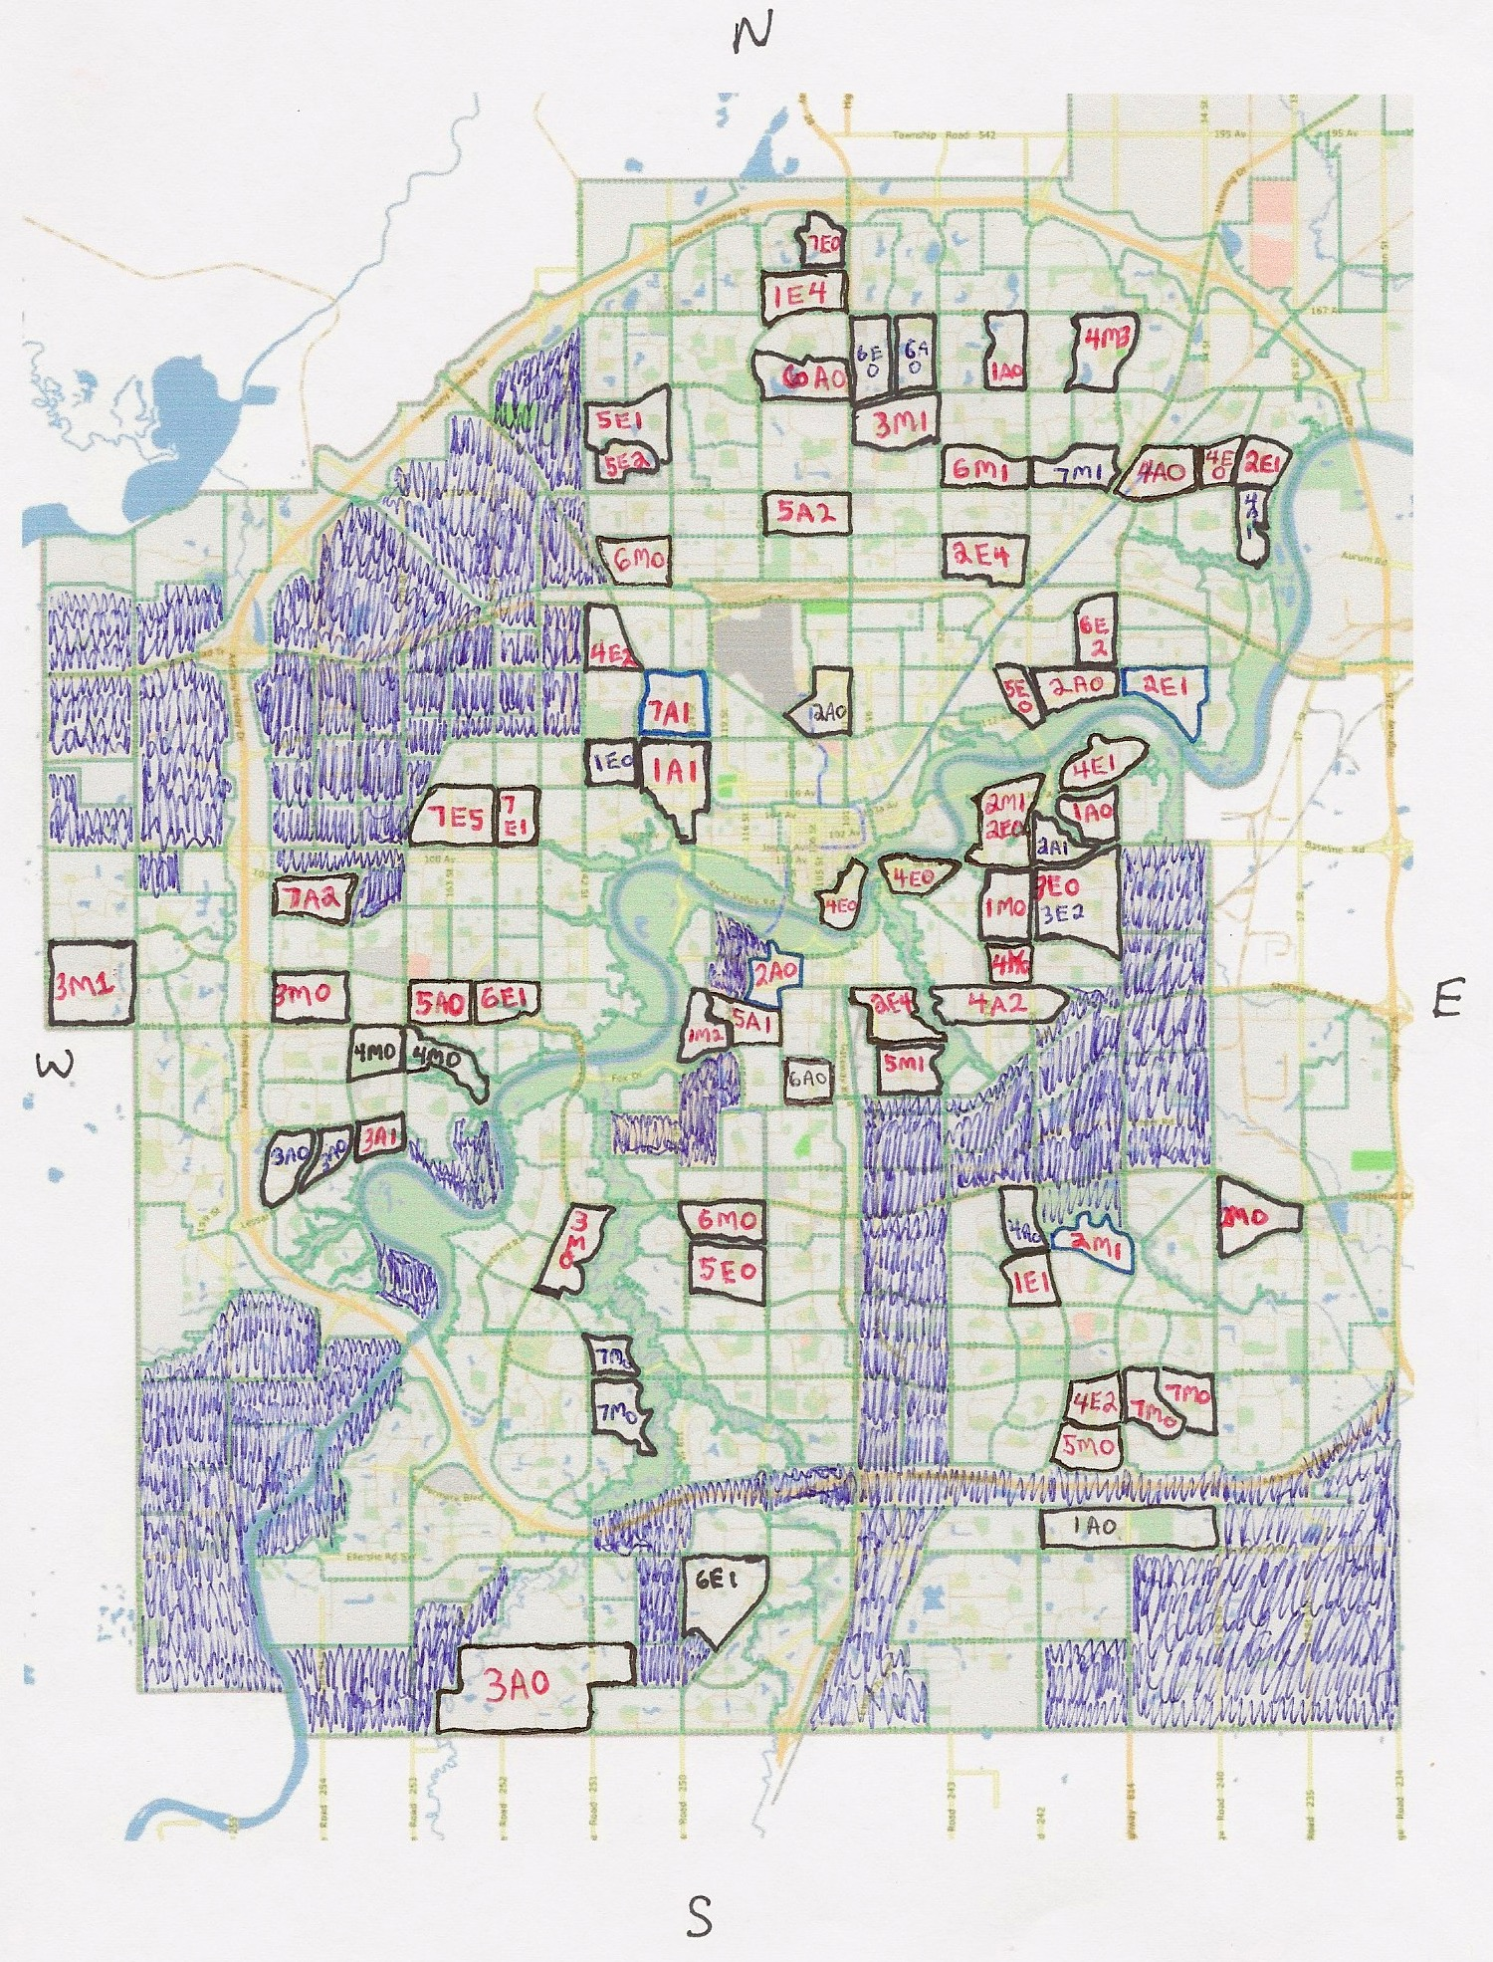  
*Figure 1. Neighborhood completion map example from Feb 15, 2019*

1. Run software on the current spreadsheet data to generate the sampling charts that summarize distances ran at every hour of the day for each day of the week. An example of these sampling charts is provided in Figures 3 and 4.
2. The runner considers his daytimer, the availability of the family car and weather forecasts. Physical and mental disposition of the runner are also key when the length of a run is matched to an appropriately sized neighborhood.
3. For post-legalization runs only, the finished neighborhood completion map for pre-legalization runs is considered. Give priority to neighborhoods that can be run at the same time and day as a pre-legalization run.
4. Consider the previously completed run. Can the new proposed run come from a different geographic area of the city?

**Preparation for a Single Run – Route Planning**

Once a neighborhood is selected, a printout can be obtained from the Edmonton SLIM maps website15. Arbitrarily trace out a route as depicted in Figure 2 with the following goals in mind.

1. The route should start and end near the parked vehicle. The route should be representative of the neighborhood but not all roadways have to be included.
2. It is ok to run a street twice but stay on opposite sides of the road. Try to avoid alleys and minimize crossing of busy streets.
3. Use satellite versions of the neighborhood in Google Maps to confirm walkways between houses and parking areas. Satellite images are helpful for planning routes in newer residential areas however they are not up to date.
4. All pre-legalization printout routes are saved in a book. These can be referenced or even re-used for the corresponding post-legalization run.

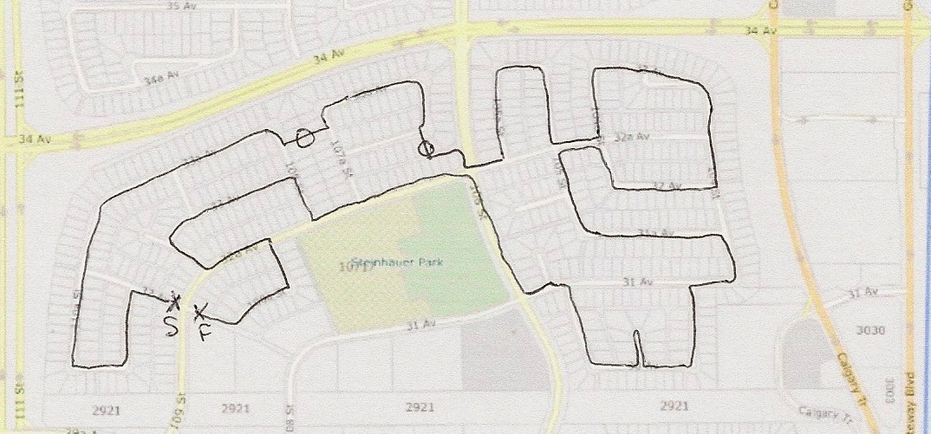

*Figure 2. Example of a sketched out run covering one neighborhood*

**Running Route Execution**

Surprisingly, there are a number of factors that can upset the planned route. Even with paper route and electronic devices handy, it is still easy to take a wrong turn! Sometimes the run is going quite well and there is time to add extra side streets. Other times the run is going poorly, or a thunderstorm is on the way so the quickest way back to the vehicle is desirable.

GPS tracking can mysteriously stop either due to technical problems or the runner inadvertently hits the pause button. Even fully charged batteries in electronic devices can quickly go to zero in -30C despite one’s attempt to keep them warm! The route printout is invaluable for accurate and successful completion of a run.

**Pre-Legalization Sampling Summary**

The following two charts summarize pre-legalization sampling at various hours of the day and days of the week. 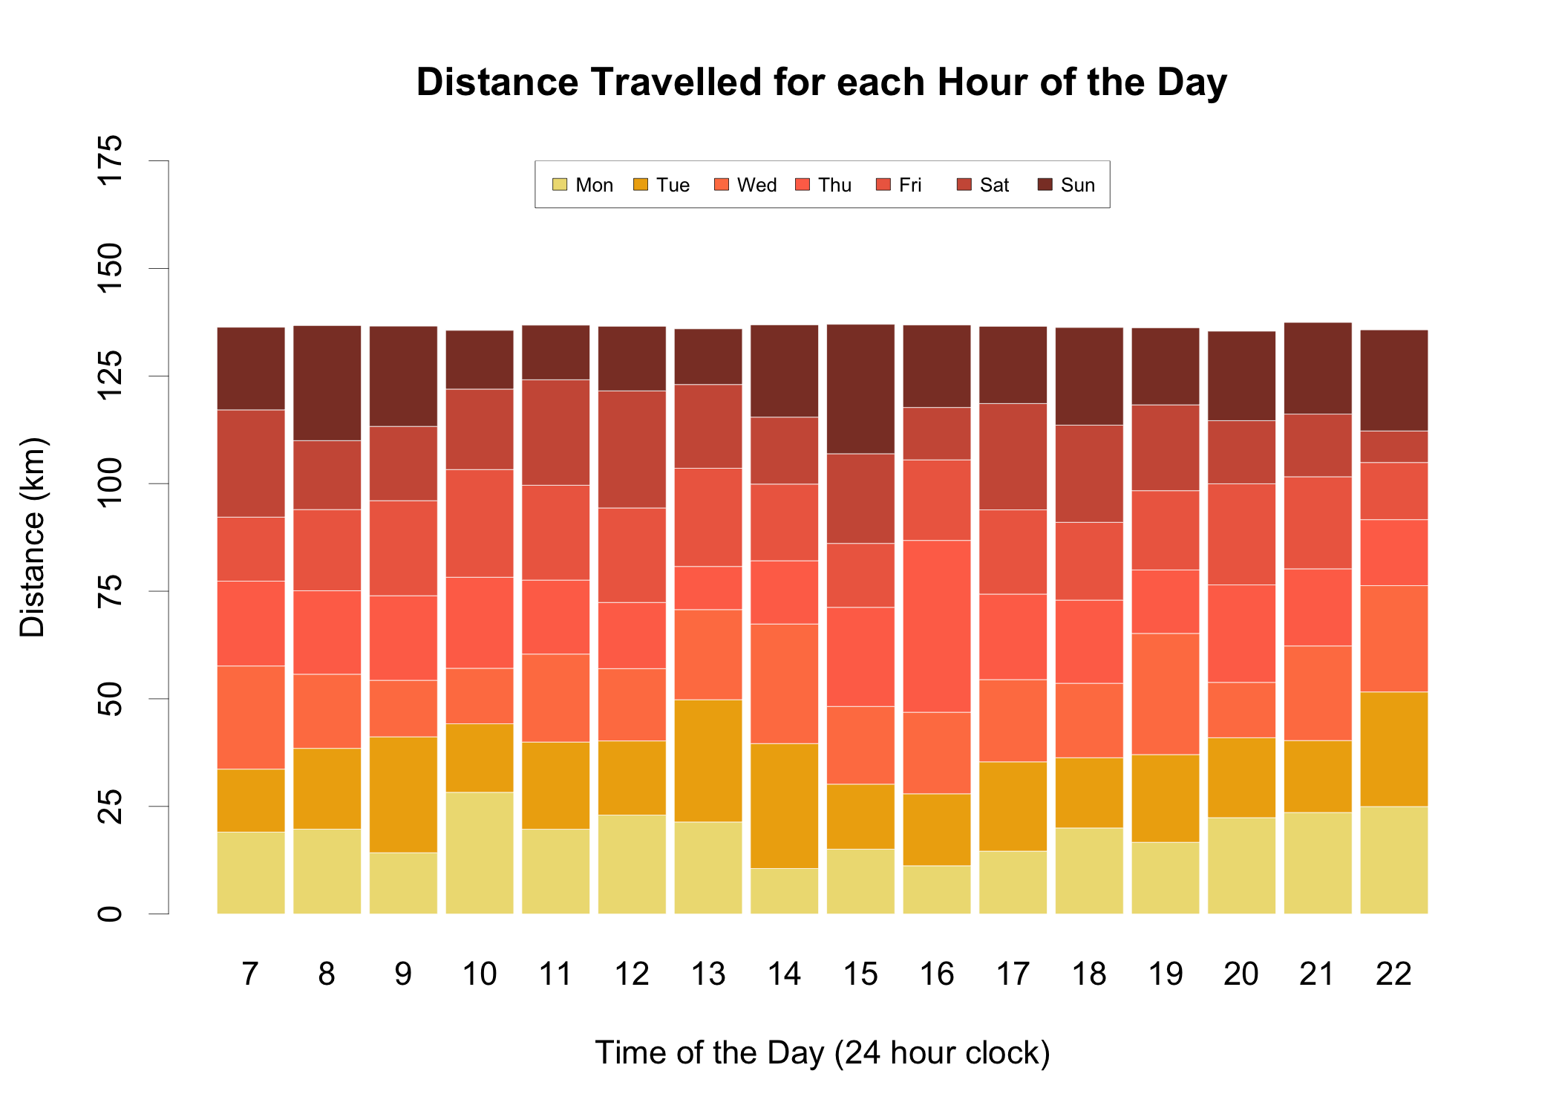

*Figure 3. Pre-Legalization Running Distance Totals for each hour*

*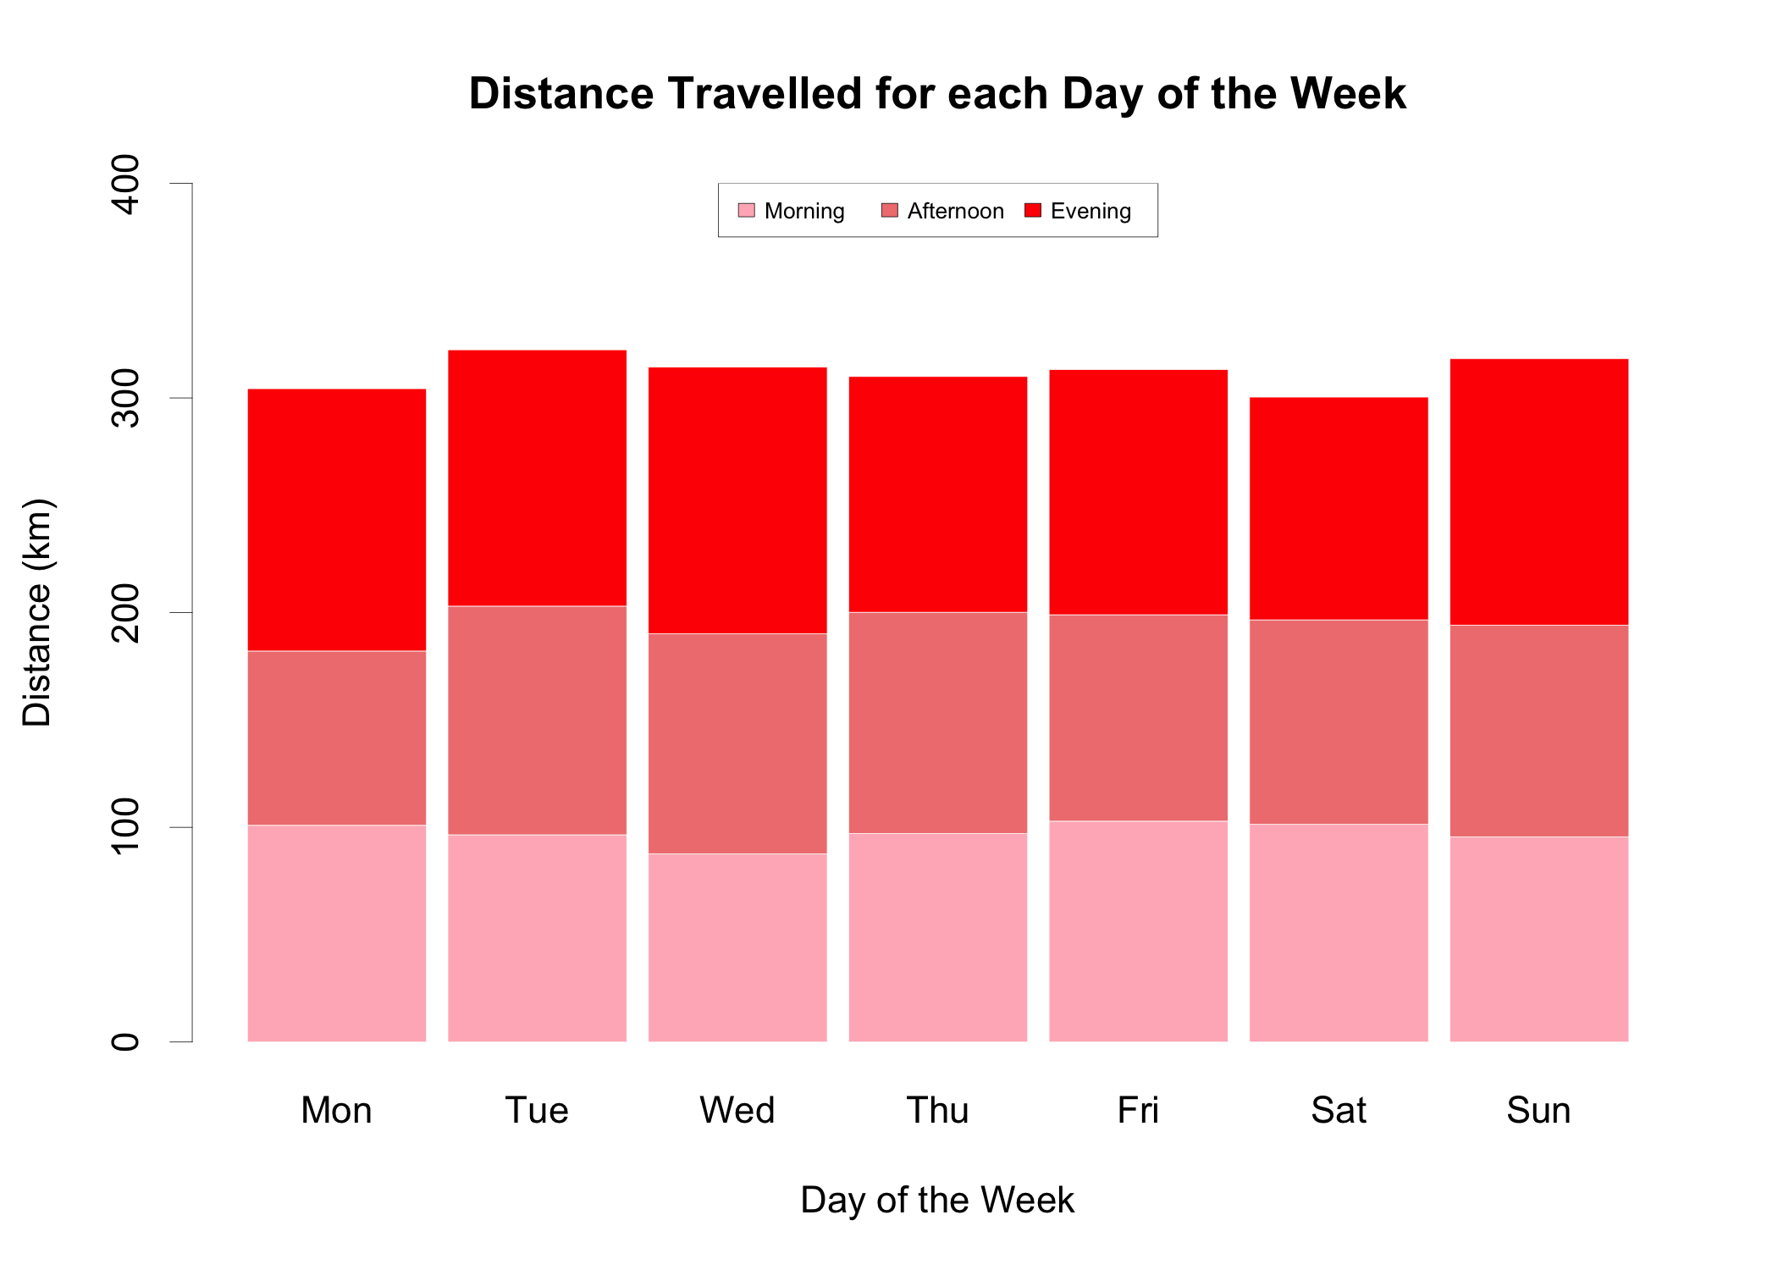*

*Figure 4. Pre-Legalization Running Distance Totals for each day of the Week*

**Post-Legalization Sampling Summary**

The following two charts summarize post-legalization sampling at various hours of the day and days of the week.

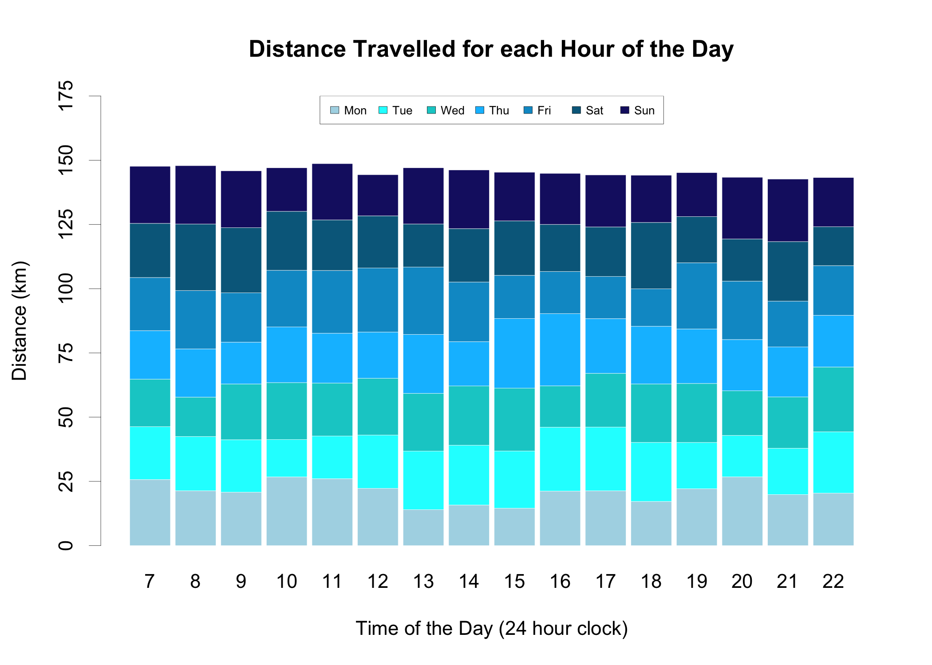*Figure 5. Post-Legalization Running Distance Totals for each hour*

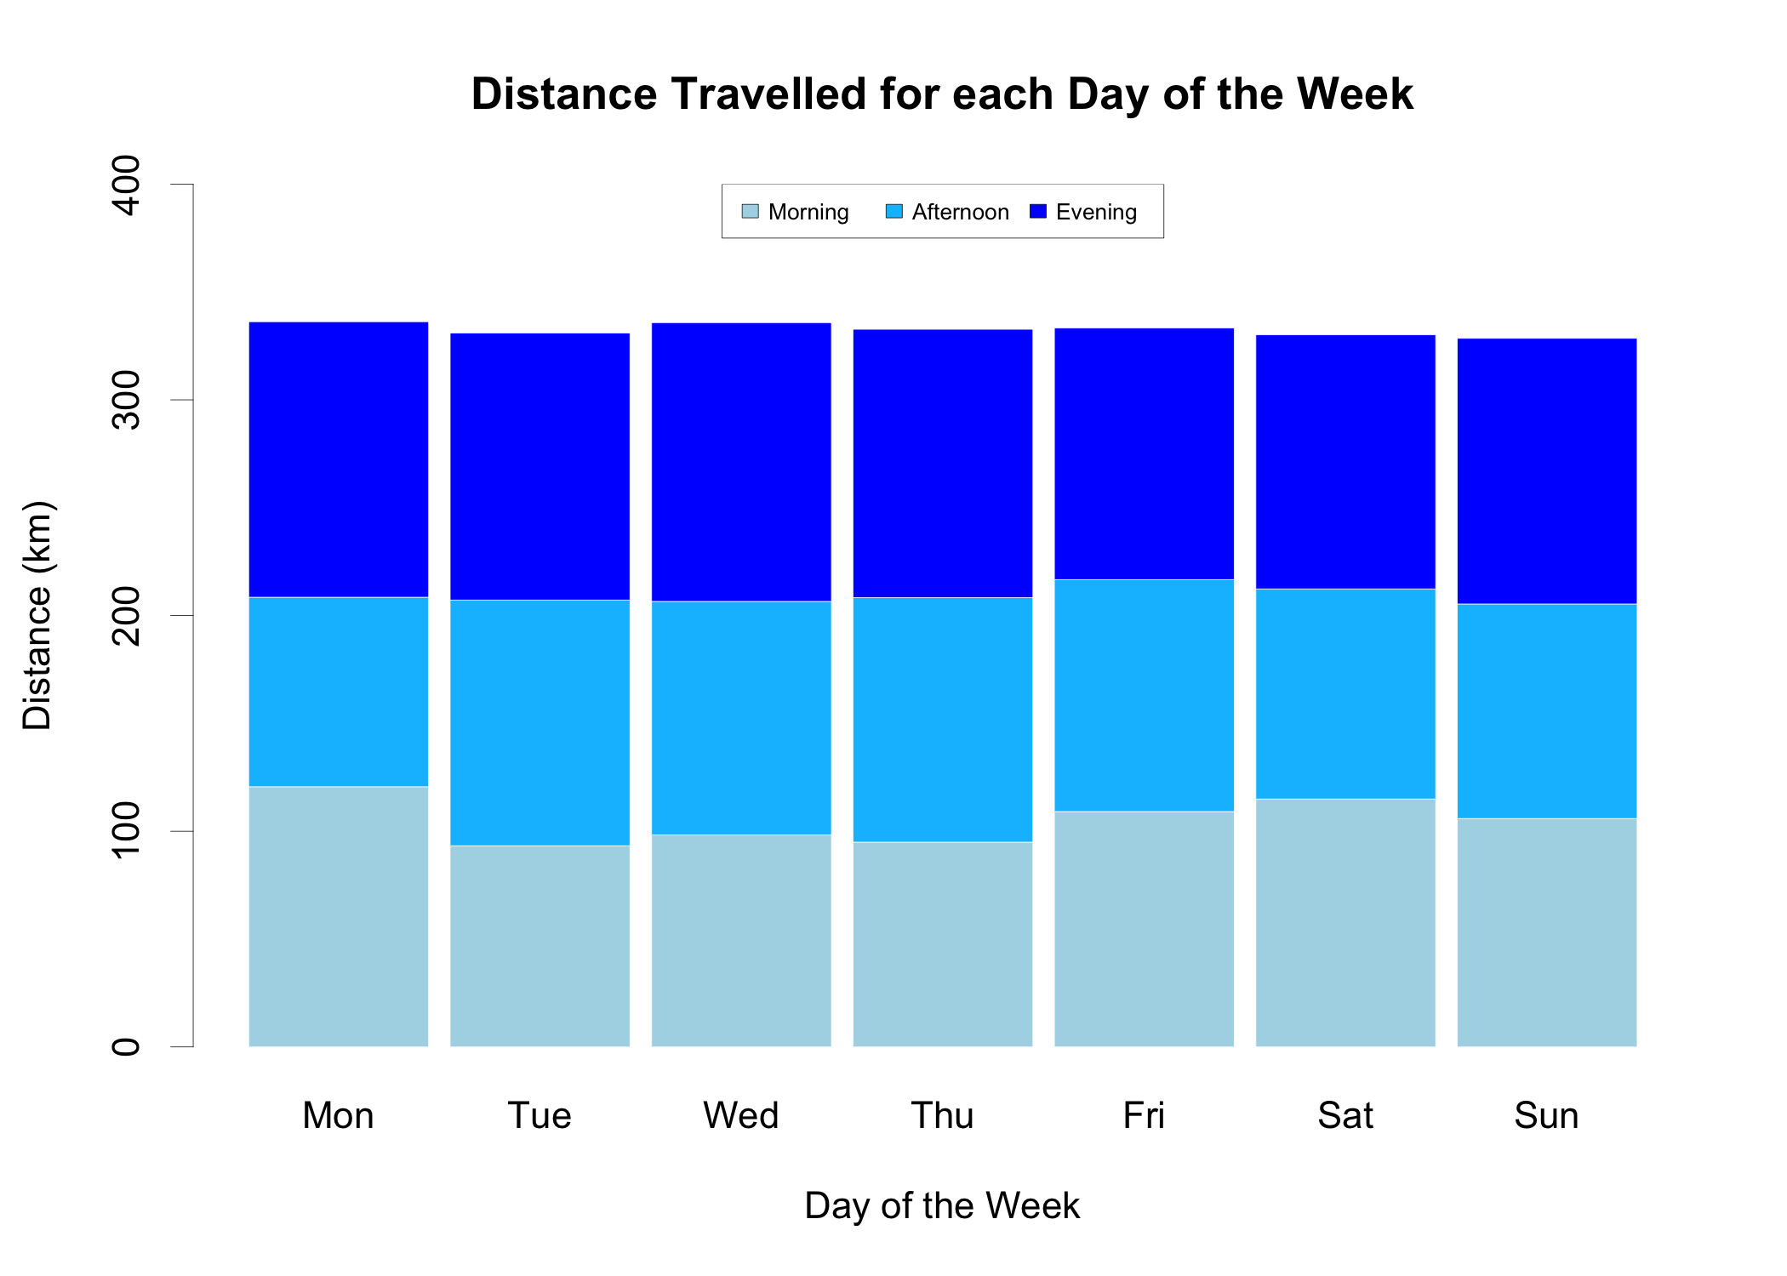

*Figure 6. Post-Legalization Running Distance Totals for each hour*

**Pre-Legalization Running Routes Summary**

The map below summarizes the 2189 kilometers of Strava data from all pre-legalization runs in the study16. The map is important for identifying the residential areas of the city and allows the reader to make sense of the hits map found in the results section. The heavier concentration of runs in the central east part of the map is due to convenience of running in areas where motorized transportation is not needed.

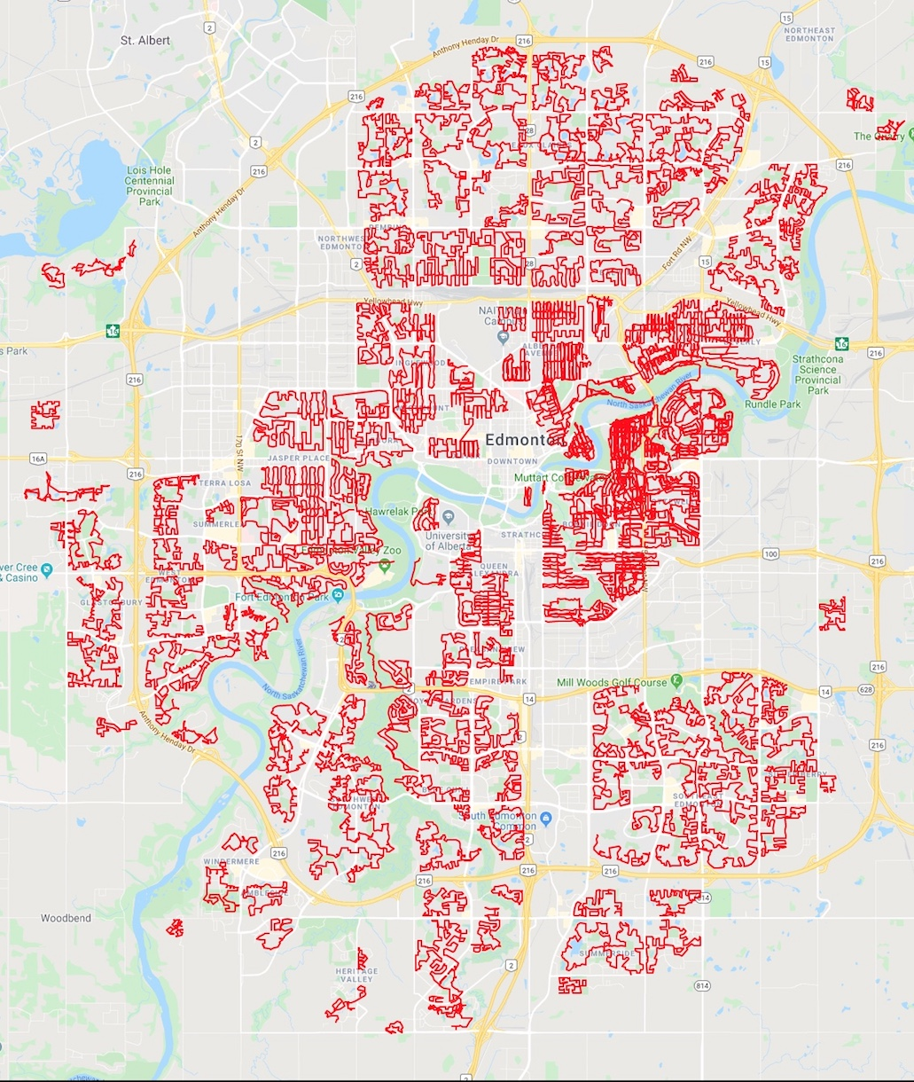

*Figure 7. Pre-legalization Route Map Summary*

**Post-Legalization Running Routes Summary**

Similarly, the map below summarizes the 2328 kilometers of Strava data from all post-legalization runs in the study. Note that this data seems sharper than pre-legalization and it is. All this data was collected using an iPhone which records GPS coordinates more accurately and is more reliable than the previously used Garmin watch. Also, the lack of a time restriction on post-legalization data allows for a better job of methodically covering each neighborhood.

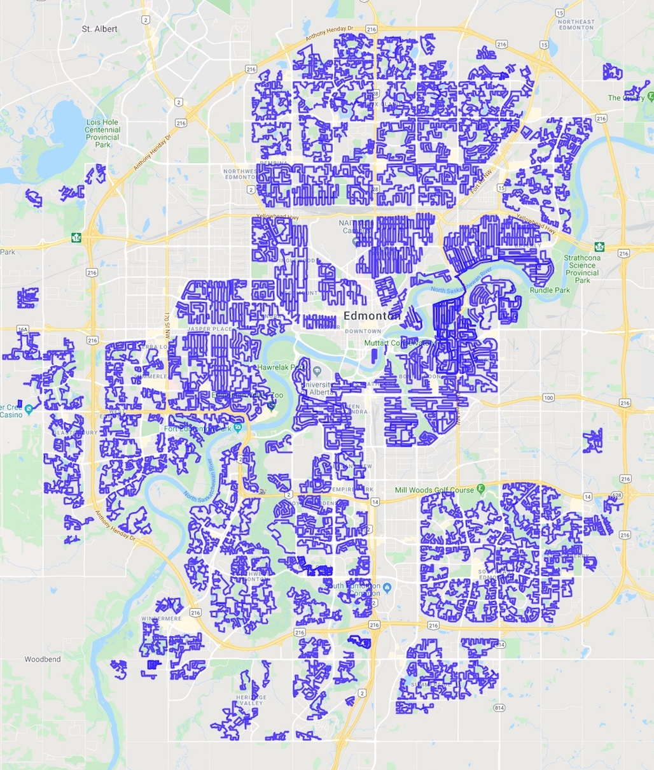

*Figure 8. Post-legalization Route Map Summary*

**Results**

The most interesting results from the study are presented below. Supporting data files are saved in csv format and all graphs and statistics are generated through software written in R. Both software and data are publicly available on github 17.

**Result 1: Analysis of Total Hits as a Function of the Legalization Date**

Before legalization, 164 cannabis detections were identified spanning 2189 kilometers of residential area whereas after legalization 219 detections were found spanning 2328 kilometers. This would suggest an overall increased usage of cannabis within residential areas of 25.6% after legalization. A 95% confidence interval for the increase in residential use of cannabis is 4% at the low end and 47% at the high end. Calculations based on the binomial approximation to a normal are given in Appendix B.

Although the result is statistically relevant, this does not necessarily imply that more people are using recreational marijuana. One possibility is that people who used cannabis at home before legalization are somewhat less inhibited to use the product after legalization.

**Result 2: Hit Distribution as a Function of City Geography**

A map giving the location of each cannabis hit is shown on the following page in Figure 9. The cannabis hits detected before legalization are the red squares and those after legalization are represented with blue circles. The map was generated with the aid of Google Maps and ggmap within R18 19.

This terrain map is presented to give the reader a sense of how various regions contributed to the final counts. Readers are welcome to look for patterns in Figure 9 with the aid of Figures 7 and 8, however the study cautions that such localized analysis is speculative at best. There is simply not enough data to compare individual neighborhoods before and after legalization. It would also be unfair compare two different neighborhoods because each neighborhood is tested under different circumstances and not all neighborhoods have the same density of housing or setbacks.

As an example, locate the cluster of post legalization hits just west of highway 216. This cluster is most likely the result of sampling a particular large neighborhood under perfect conditions as opposed to any intrinsic change due to legalization. 20

A further discussion comparing hit frequency found within specific city wards is given in Appendix C.

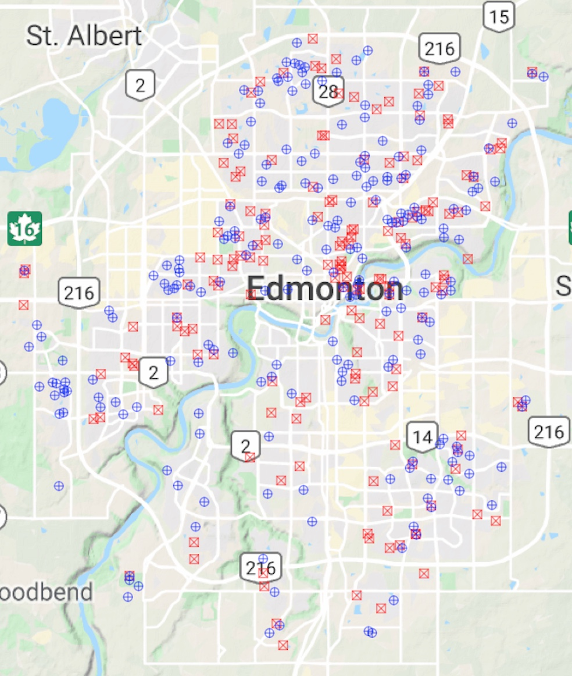

*Figure 9. Location of hits, red square = pre-legalization, blue circles = post-legalization*

**Result 3: Hit Distribution as a Function of the Time of Day**

When comparing the time of the day for hits pre and post legalization, the graphs are relatively similar. Although evening hours are most popular for cannabis use, it may surprise some readers that daytime use is not insignificant. Although the study does not acquire data after 11pm, the hour leading up to 11pm has the most hits. Readers should be aware that a large number of homes are unlit after 10pm implying a declining sample size, however this may be offset with lighter evening winds which increases the propensity to detect hits.

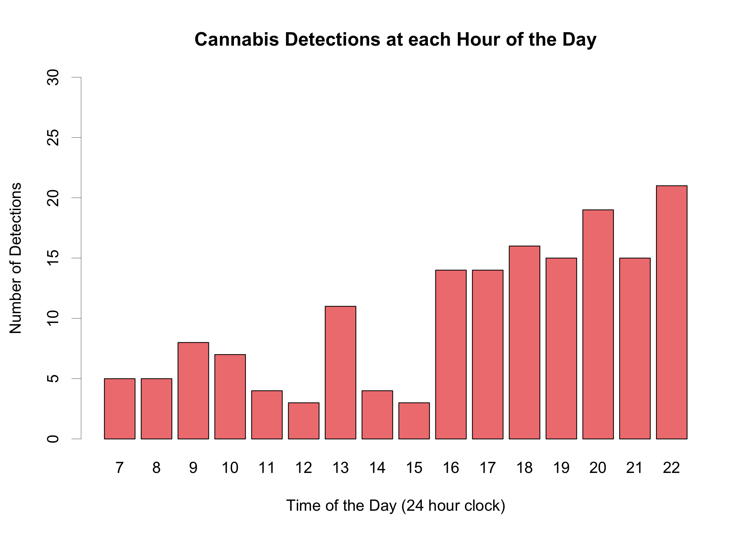

*Figure 10. Number of detections over the course of the day – Pre legalization*

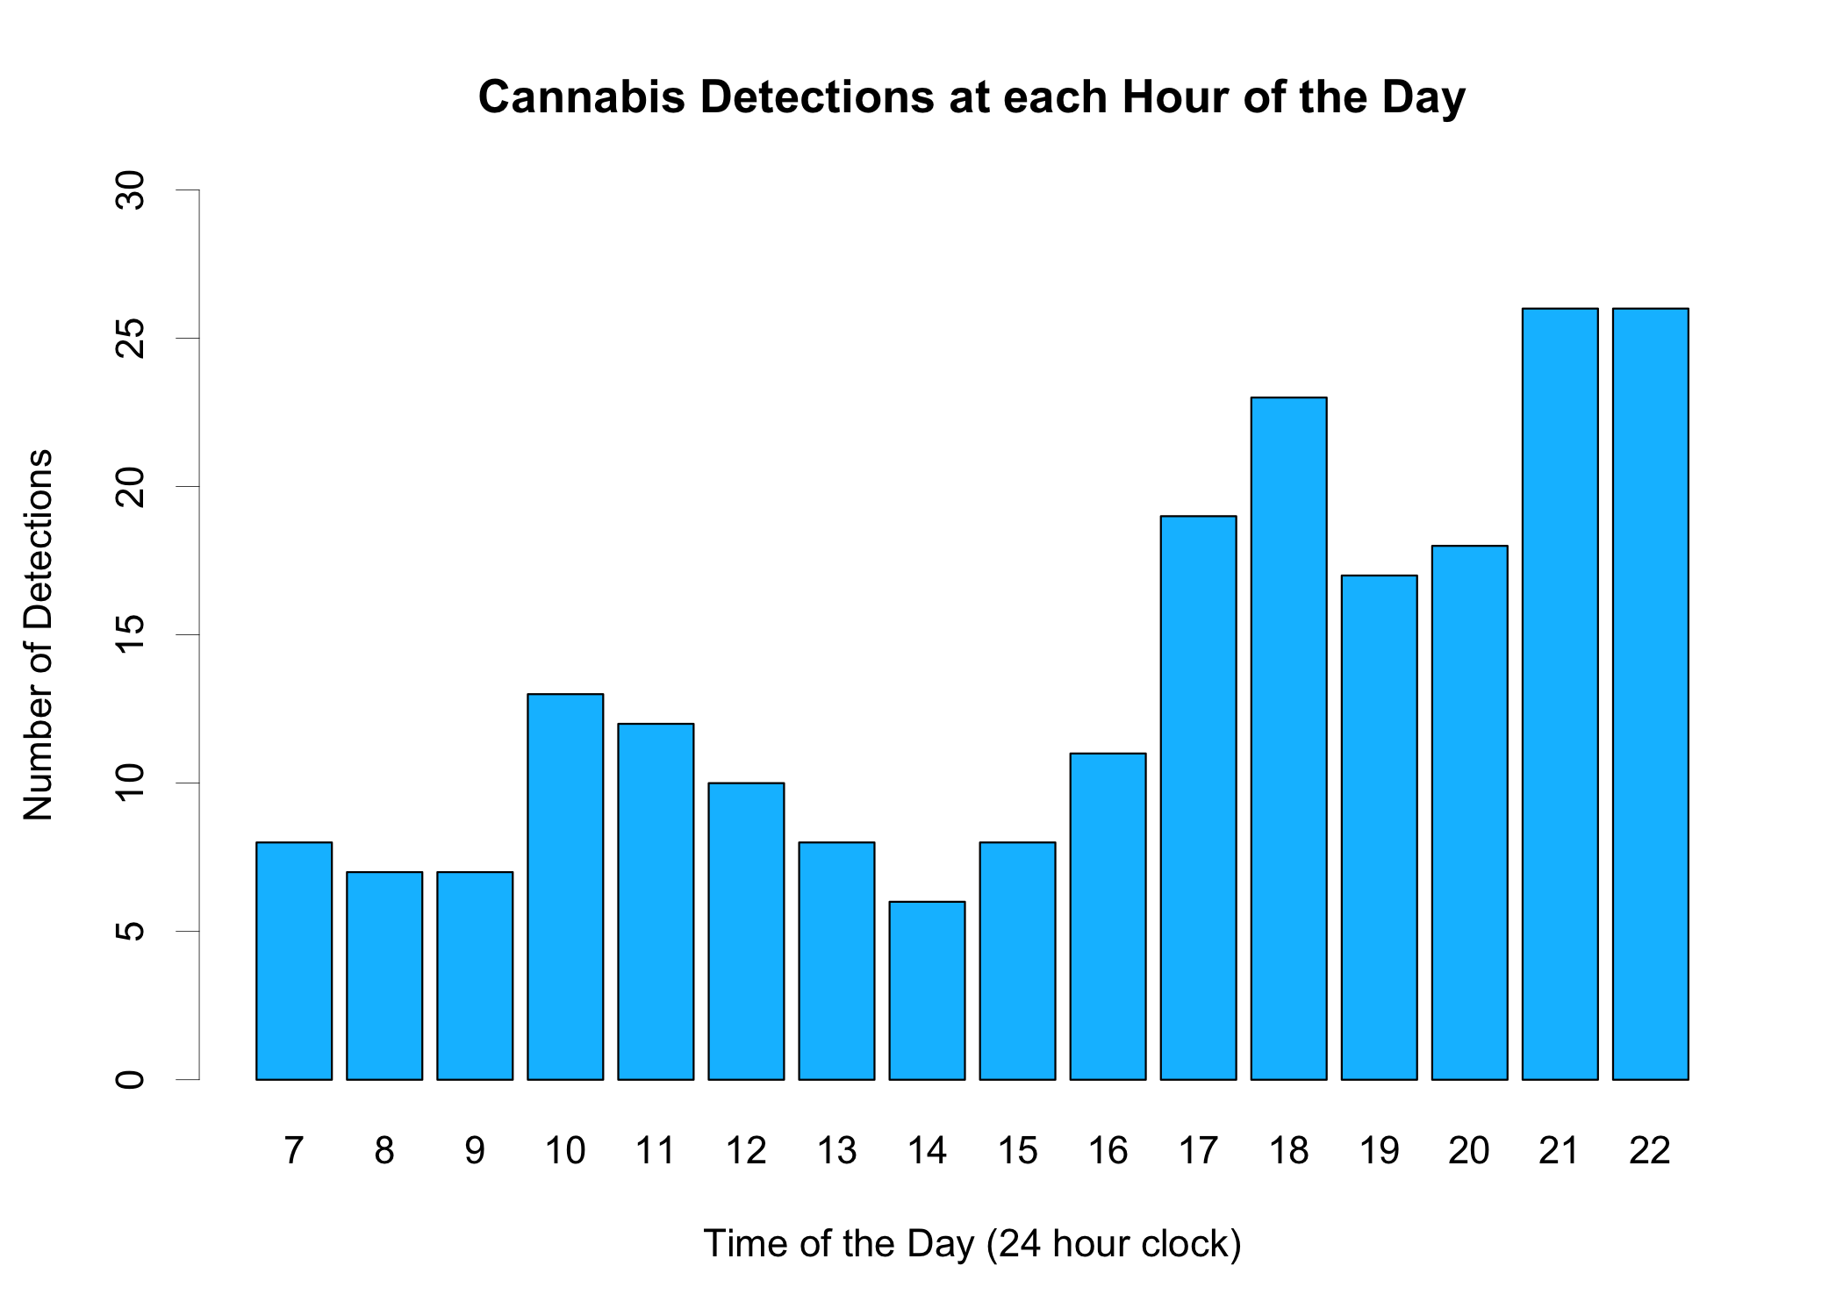

*Figure 11. Number of detections over the course of the day – Post legalization*

**Result 4: Hit Distribution as a Function of the Day of the Week**

It was surprising to see so many pre-legalization hits for Mondays, however this trend did not continue post-legalization. Thursdays are typically linked with social events which is the best explanation for these high counts. Friday evenings and weekend counts are lower than expected. Could this be the result of people just not being home for the weekend?

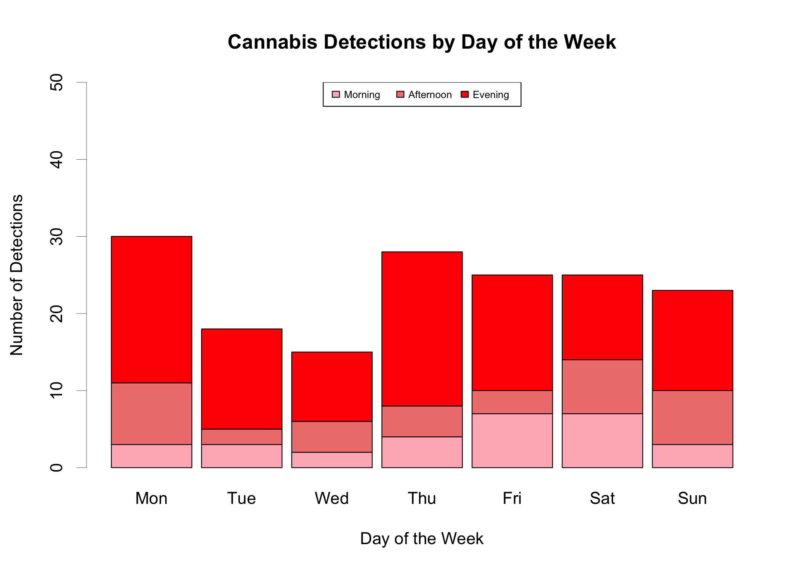

*Figure 12. Number of detections over the days of the week – Pre legalization*

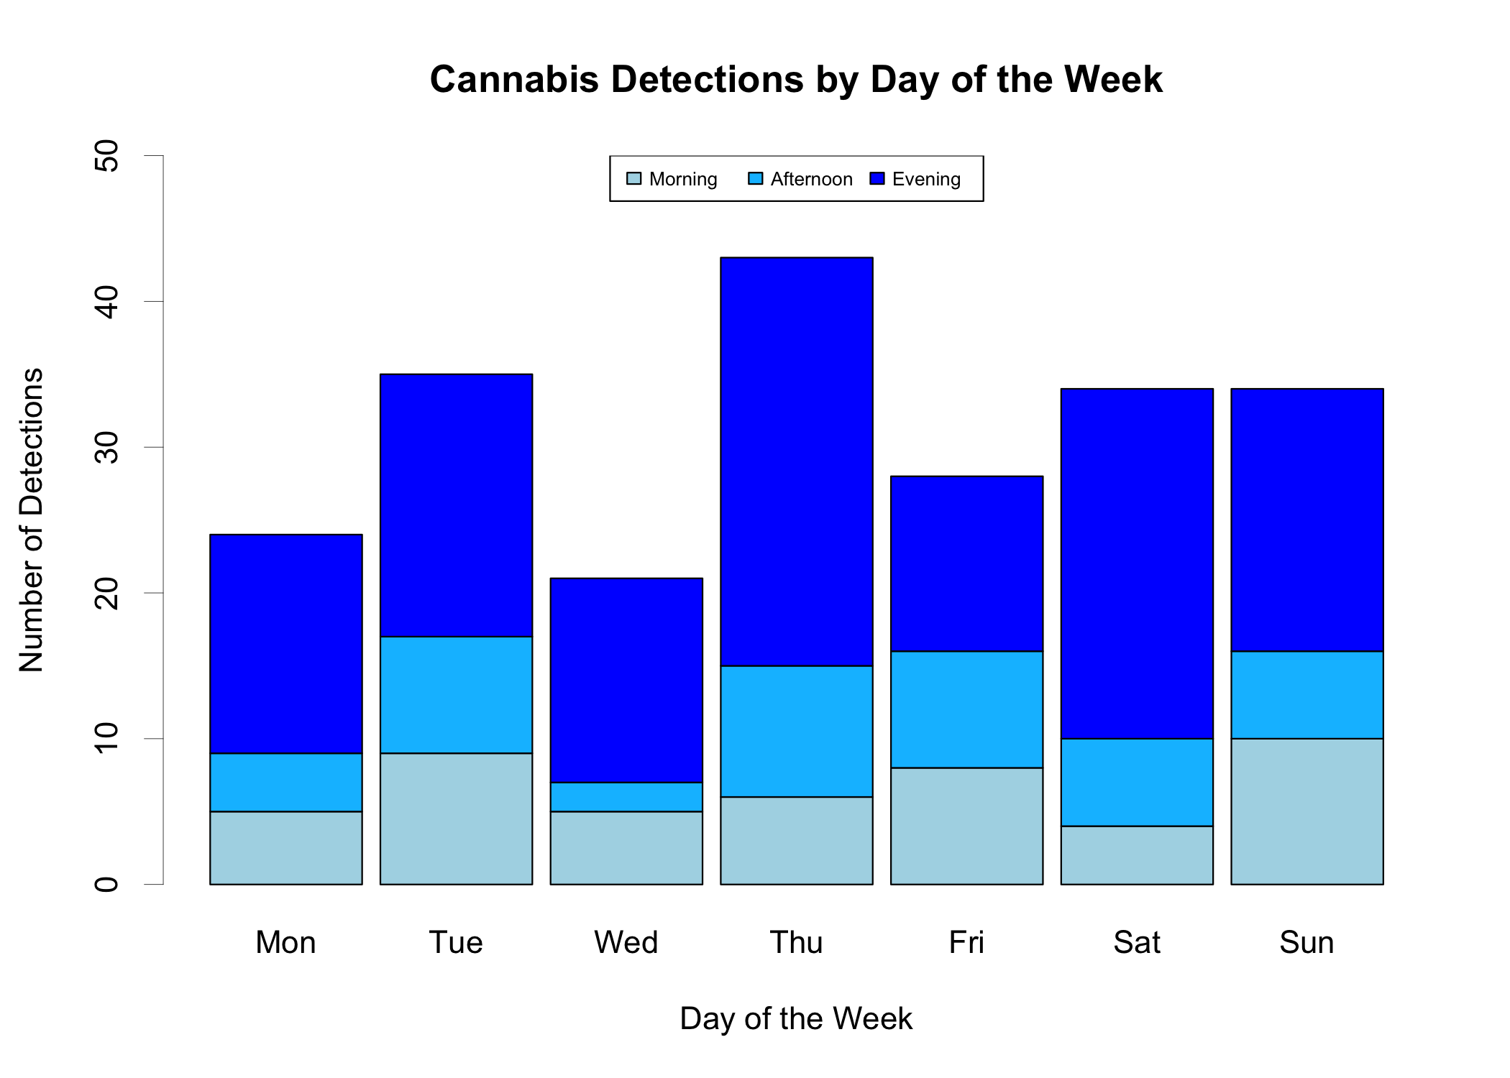

*Figure 13. Number of detections over the days of the week – Post legalization*

**Result 5: Hit Distribution in Terms of Trends and Seasonality**

The following two figures help the reader understand how the average distance ran between hits changes over time. The horizontal red line at 13.35 km is the overall average distance between hits pre-legalization; each red circle is the moving average of the last 20 hits. The corresponding blue line at 10.6 km and blue circles represent the post-legalization data. Both graphs work in tandem to help the reader visualize the trends. One can speculate that increased usage in December may be due to Christmas holidays and gatherings, decreasing use in residential areas in July may be due to summer holidays. The trend in residential usage appears to be increasing.

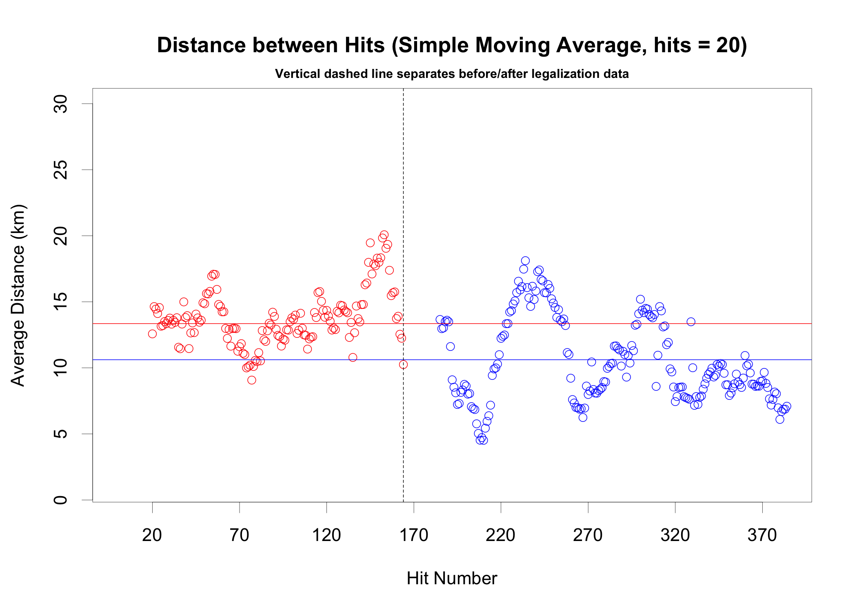

*Figure 14. The average distance between hits of the last 20 hits*

**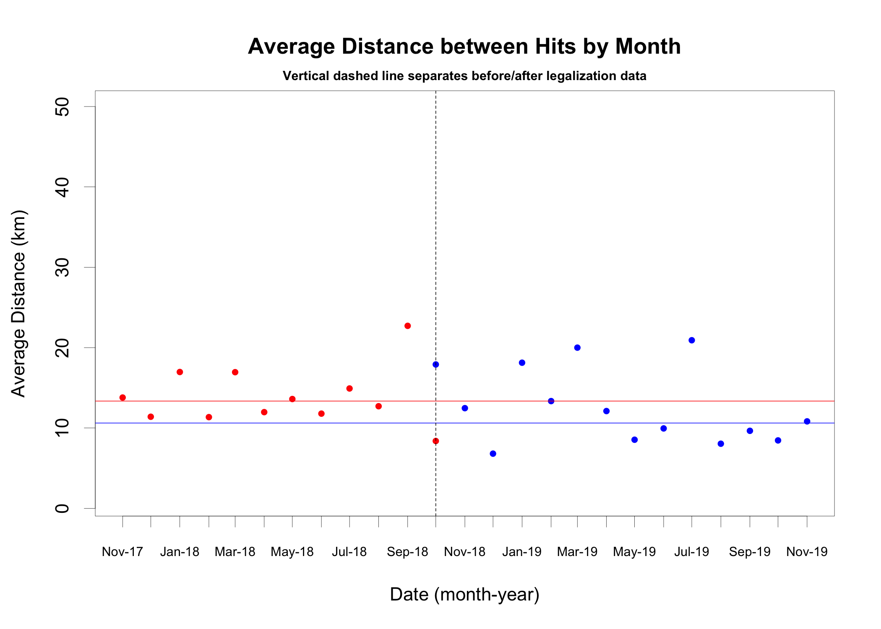**

*Figure 15. The average distance between hits as a function of each month*

**Result 6: Hit Distribution as a Function of Average Neighborhood Income**

The software calculates the average neighborhood income using the data from Open Edmonton. Although these results suggest that cannabis usage is a function of income, the reader should be aware that the most affluent neighborhoods typically have less density and greater setbacks thereby leading to fewer hits.

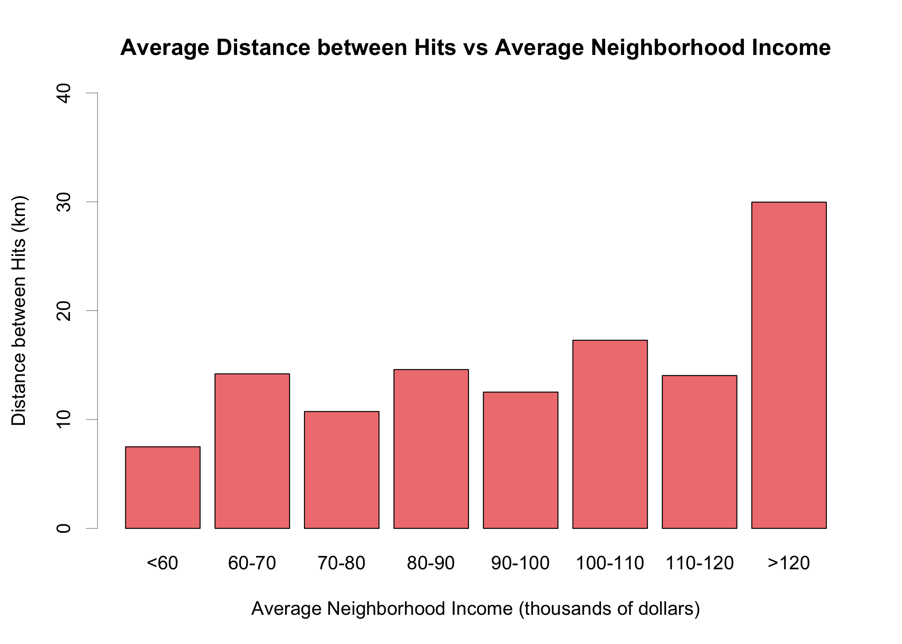

*Figure 16. Pre-Legalization: The average distance between hits as a function of Average Income*

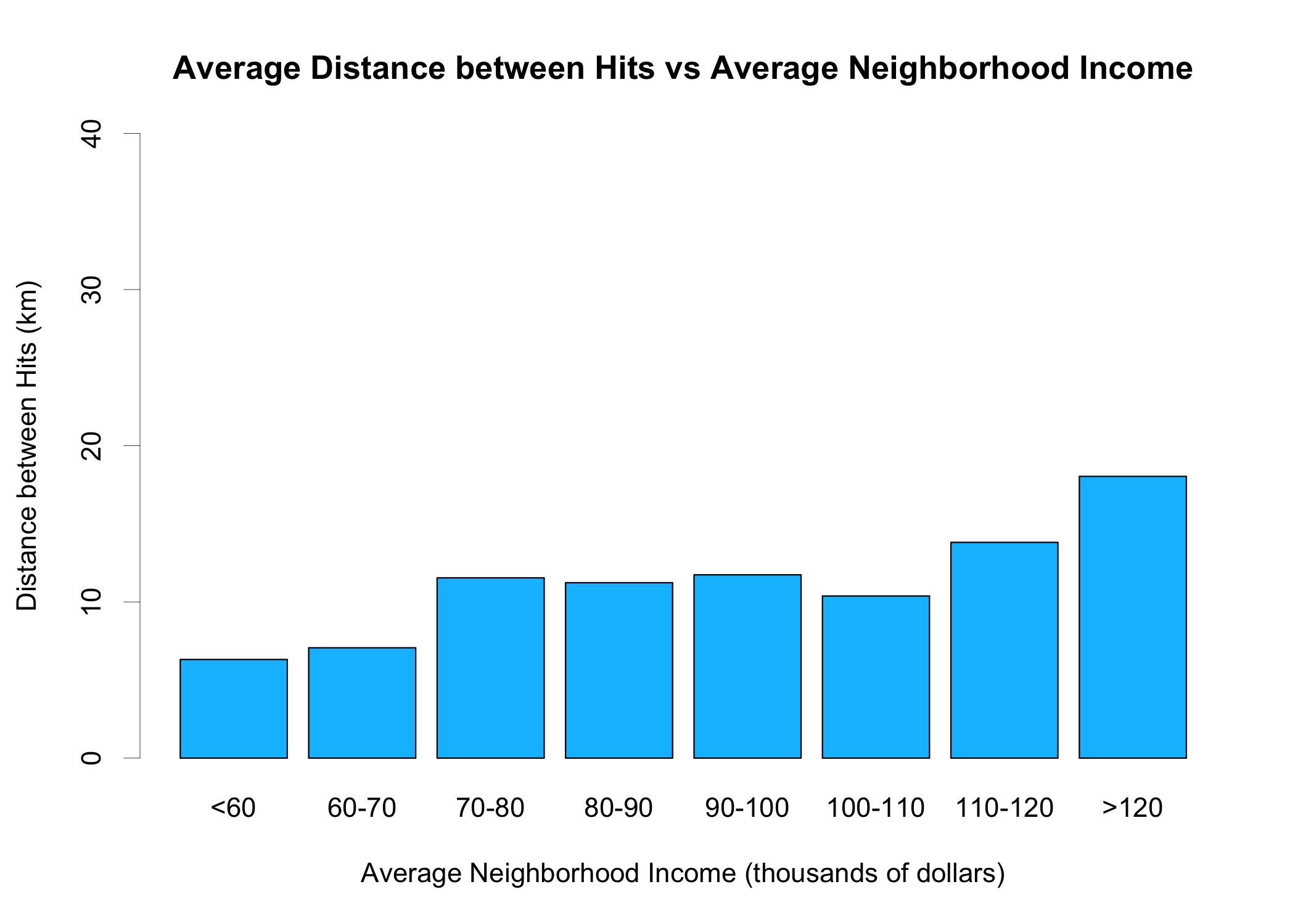

*Figure 17. Post legalization: The average distance between hits as a function of Average Income*

**Result 7: Hit Distribution as a Function of Average Neighborhood Age**

As the average age of a neighborhood increases, the trend is an increase in cannabis use. Perhaps what is noteworthy in these charts is that the youngest and oldest neighborhoods seem virtually unaffected by cannabis legalization whereas the neighborhoods in the 34-44 average age account for all increased use after legalization.

**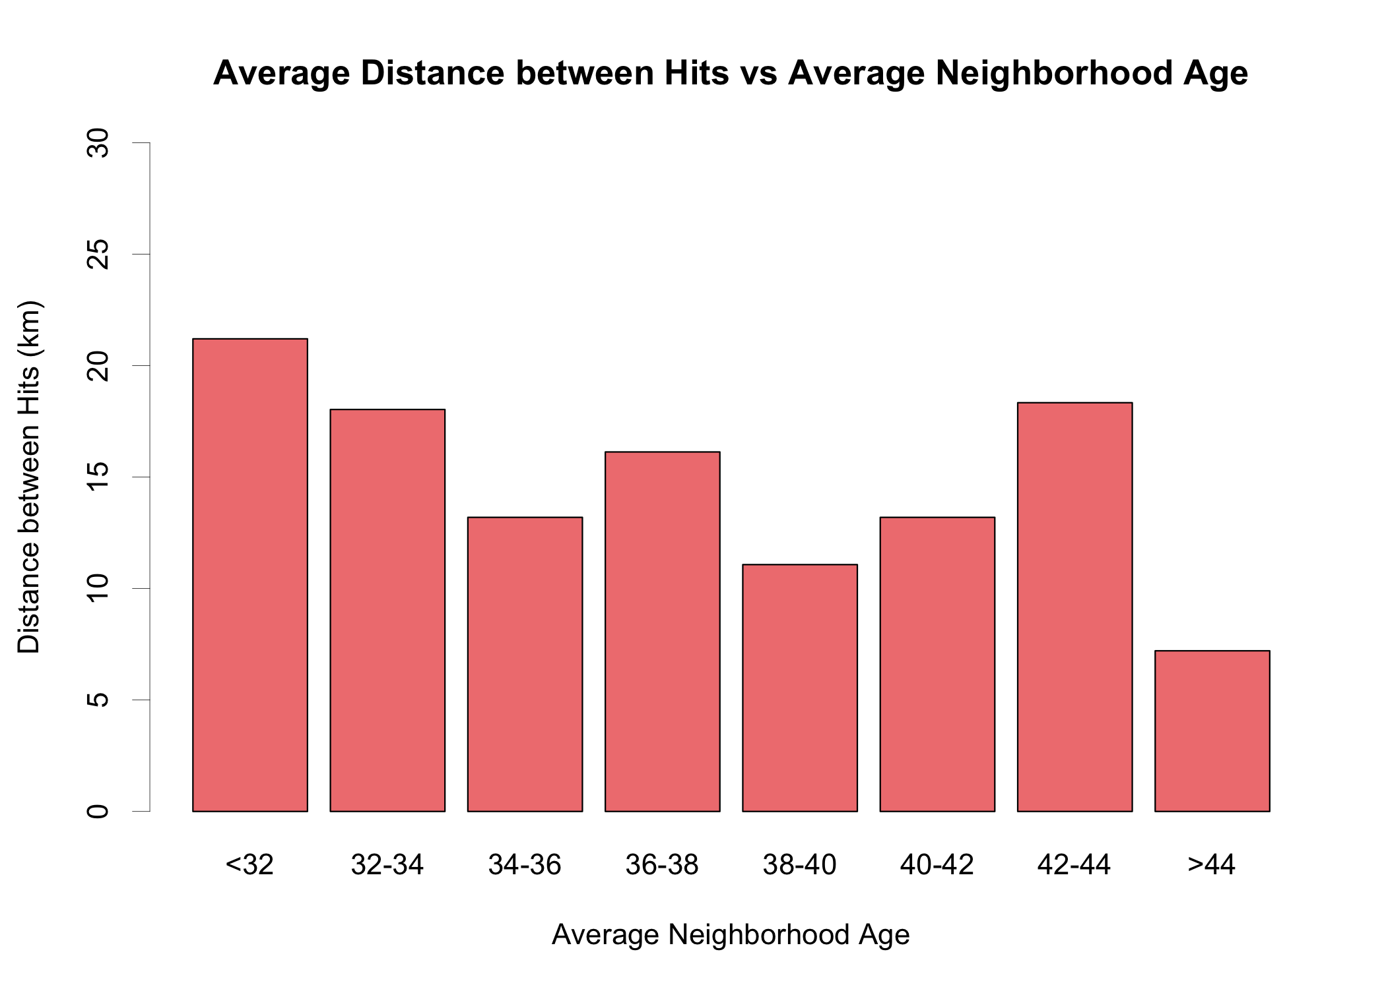**

*Figure 18. Pre-Legalization: The average distance between hits as a function of Average Age*

**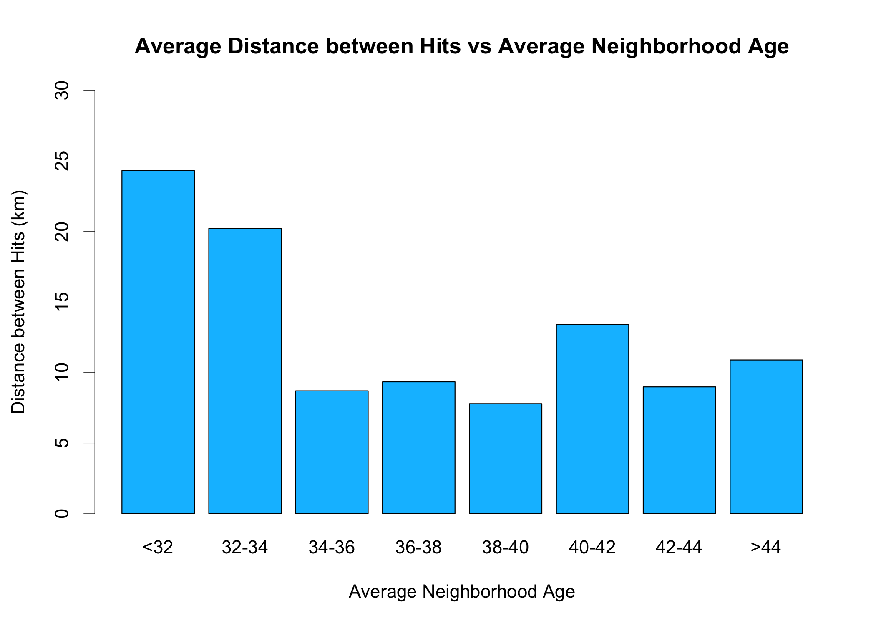**

*Figure 19. Post legalization: The average distance between hits as a function of Average Age*

**Result 8: Multiple Poisson Regression of Independent Variables on Hits**

Up to this point we have looked at variables in isolation and their possible effects on pre and post legislation cannabis counts. We complete our analysis by considering the simultaneous interaction of all the variables upon hits. Poisson regression is an appropriate model for our study since the dependent variable is a rate (i.e., the number of hits over a distance ran).

Here are the independent variables under consideration in the regression, note that the last 3 are treated as categorical.

1. **Pace**: Are hits more likely at a slower pace?
2. **Wind Speed**: Are hits more likely on a calm day?
3. **Temperature**: Does it matter if it is cold or hot outside?
4. **Average age of people in the neighborhood**: The average age is calculated by a script using the 2016 census data at Open Edmonton.
5. **Average income of people in the neighborhood**: The average income is calculated by a script using the 2016 census data at Open Edmonton.
6. **Geography**: Edmonton is divided into 12 separate districts or wards. Are hits more likely in certain wards?
7. **Day of the Week**: Do some days favor more/less hits?
8. **Time of Day**: Rather than consider each hour of the day, this data is condensed into 2 categories (before regular work hours 7AM to 5PM and after regular work hours 5PM to 11PM)

Statistically output and details from the run are discussed in Appendix D.

It is no surprise that the time of day is a significant factor as well as Income. However income is also tied to lower density and greater setback so despite what the numbers say, I would not make any conclusions here. It is interesting that outside temperature is not significant because I would have thought a nicer day would lead to more recreational cannabis users.

## Acknowledgements

There are many people to thank in a comprehensive study like this starting with my wife Silvia who was very understanding of my crazy running schedule and the sharing of a single family car. I also thank all my editors (Barb, Helen, Silvia, Ian, OJ, Sue Ann, Michelle, Jeff) who offered kind criticism/enthusiasm for my project and paper. As a software writer, I was particularly grateful to those people who provided free tools especially in mapping and statistics and to the city for provided demographic data. Finally, it was a pleasure to run in neighborhoods to see people being active and have people wave as I pass by.

## References and Footnotes

1. See <https://www.linkedin.com/in/robertboyko/> for a publication history.

2. Statistics Canada. National Cannabis Survey, first quarter 2019. Ottawa, ON: Statistics Canada; 2019. [Accessed 2020 Jan 27]. See [https://www150.statcan.gc.ca/n1/en/daily-quotidien/190502/dq190502a-eng.pdf?st=TQEzeqzW](https://www150.statcan.gc.ca/n1/en/daily-quotidien/190502/dq190502a-eng.pdf?st=TQEzeqzW" \t "_blank).

3. Yes, I know I should be citing reputable sources for this statement. But anecdotally, I have analyzed data where a seemingly innocuous change in the question leads to statistically significant results. I have worked on surveys where I had a way to verify that the response of the survey taker was in accordance with his/her action and the difference, whether intended or unintended, greatly subverted the quality of the data. Surveys seem so innocuous but they are really, really hard to get right!

4. Tracking the Trends 2018, Edmonton Social Planning Council, See <https://www.edmontonsocialplanning.ca/index.php/resources/digital-resources/a-espc-documents/a06-newsletters/a06f-tracking-the-trends/1050-tracking-the-trends-2018/file>, Page 4.

5. I am basing this opinion on the 2019 Federal and Provincial election results.

6. I am basing this opinion on <https://en.wikipedia.org/wiki/Tourism_in_Canada>, Edmonton’s isolated geographic location, and the quality of local events and green space.

7. potguide.com, [access Dec 2019]. See <https://potguide.com/canada/alberta/cannabis-stores/edmonton/>

8. City of Edmonton Website, [accessed 2020 Jan 27], See <https://www.edmonton.ca/residential_neighbourhoods/your-neighbourhood.aspx>

9. I also considered other modes of transportation (other than running and walking) but in the end decided to reject them. The roads and sidewalks are too bumpy for skateboards. Since cycling cannot be done on sidewalks, it means I am slightly farther away from the property and the route is less straight because of swerving around parked cars. Driving a neighborhood in my car with the window rolled down completely undermines my fitness program!

10. One difference between smoking and vaping is that vaping takes much less time which means the window of opportunity to detect vaping is much shorter.

11. I would consider my ability to smell cannabis to be average or slightly below. I have never had a test to evaluate my nasal acuity.

12. Garmin Connect, a tool for tracking, analyzing and sharing health and fitness activities from your Garmin device, See https://connect.garmin.com/

13. Strava, a fitness-tracking app, See strava .com

14. I arbitrarily decide that the running window starts at 7am and no run goes past 11pm even though recreational cannabis use is still high. I am not going to lose any sleep over this project!

15. <https://maps.edmonton.ca/map.aspx>

16. O’Keeffe, Jonathan. See <http://www.jonathanokeeffe.com/strava/map.php>

17. I have not posted the source to github yet until the research is complete.

18. Google(n.d.), [Terrain city map of Edmonton accessed via Google Maps API].

19. D. Kahle and H. Wickham. ggmap: Spatial Visualization with ggplot2, The R Journal, 5(1), 144-161. URL <http://journal.r-project.org/archive/2013-1/kahle-wickham.pdf>

20. It was a Saturday evening, the first nice day of 2019, and so many people were out doing spring-cleaning. Too early in the year for bugs or for people to make weekend getaway plans.

## Appendix A – Results for Legalization Week: Oct 15 – 22, 2018

## The study design excludes data collected during legalization week. It was postulated that this transitional period could be unduly influenced by media attention and that usage could also be elevated due to novelty effects. The one-week transitional period was chosen arbitrarily and a priori and the results are included here mainly to satisfy the curiosity of the reader.

**Methodology:** Starting at 7am and ending at 11pm on Oct 17, 2018, 46 kilometers spanning 20 different neighborhoods were surveyed by walking only. These neighborhoods, representing all wards in Edmonton, are chosen arbitrarily. For the first weekend after legalization, there is a late morning (9km) run and an early evening run (9km). Legalization day is a beautiful day (24C) and the weekend is similar but cooler.

**Results:** There were 8 hits on legalization day and 5 on the weekend for a total of 13 hits over a distance of 64.3 kilometers.

**Conclusion:** Although the hit rate was close to triple (4.95 km/hit vs. 13.35 km/hit) there is not enough data (i.e., hits) to make any statistical conclusions. The most profound aspect of legalization week is a lot more visceral than scientific. Other than a few extra hits, you would never know that the laws actually changed.

## Appendix B – Calculation of 95% confidence interval for the percent increase in hits after legalization

## My apologies for this scribbling, but I am probably the only one who cares ☺

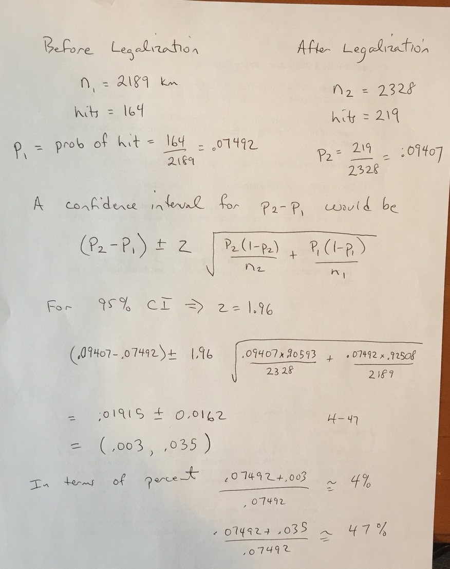

## Appendix C – Hit Frequency as a Function of City Wards

Another possible consideration for geography is to compare average distance between hits as a function of city ward. Edmonton is divided into 12 wards as displayed below.

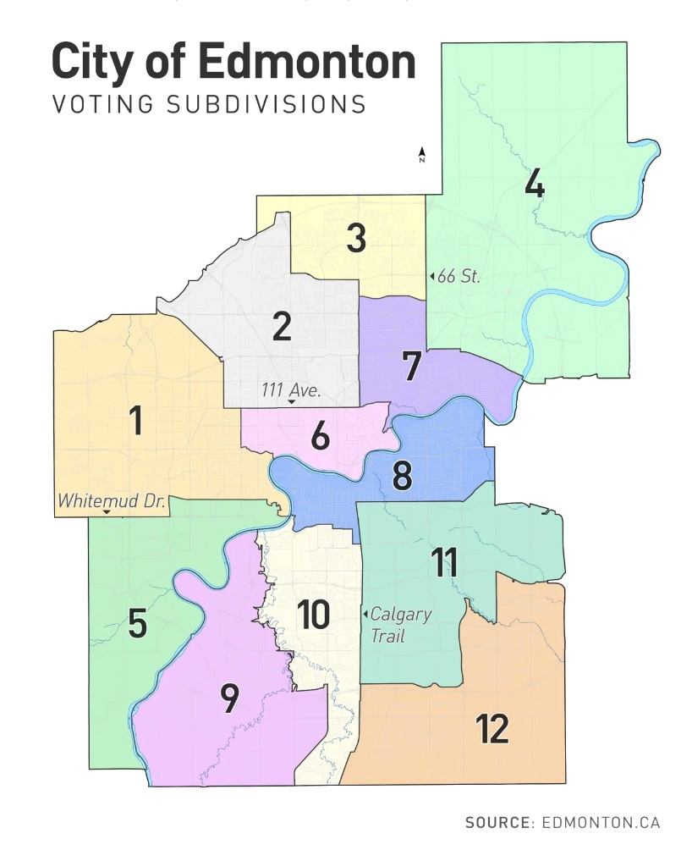

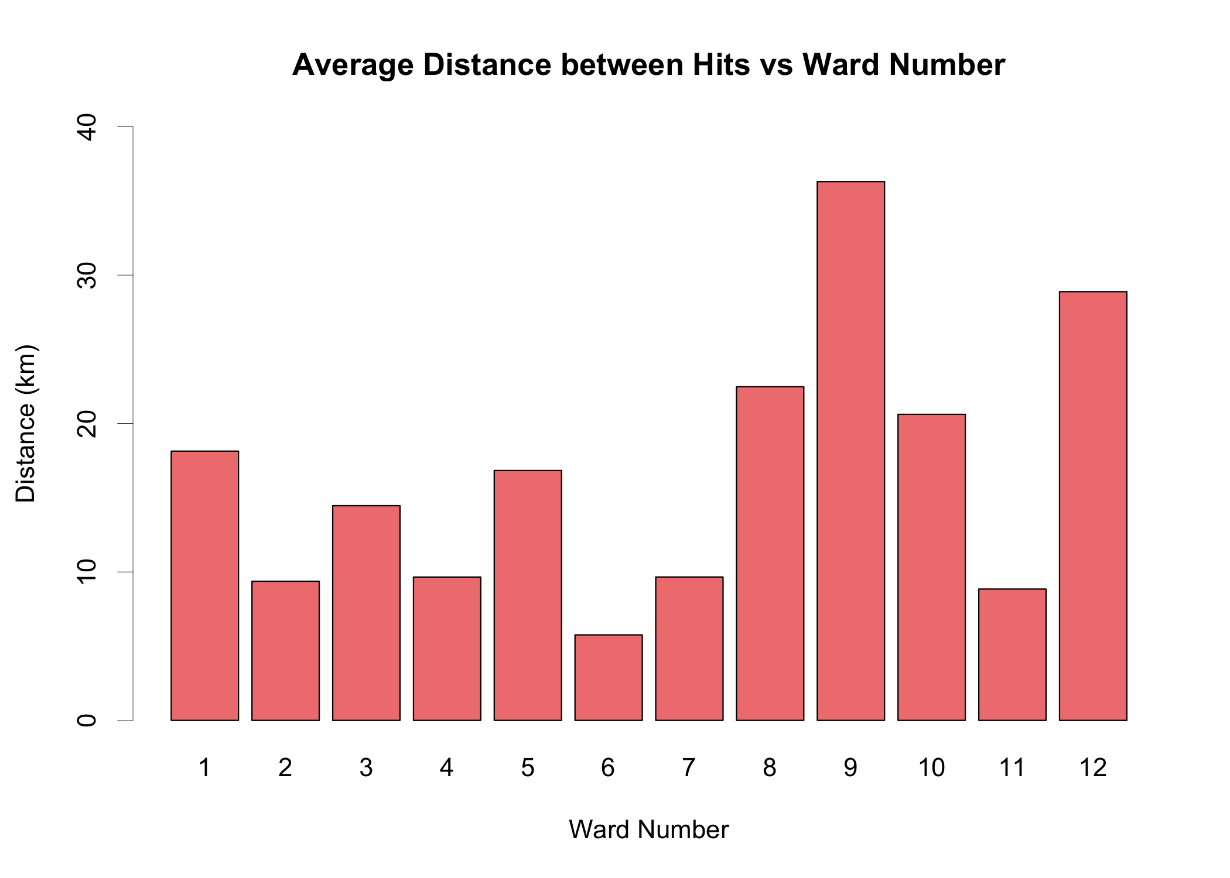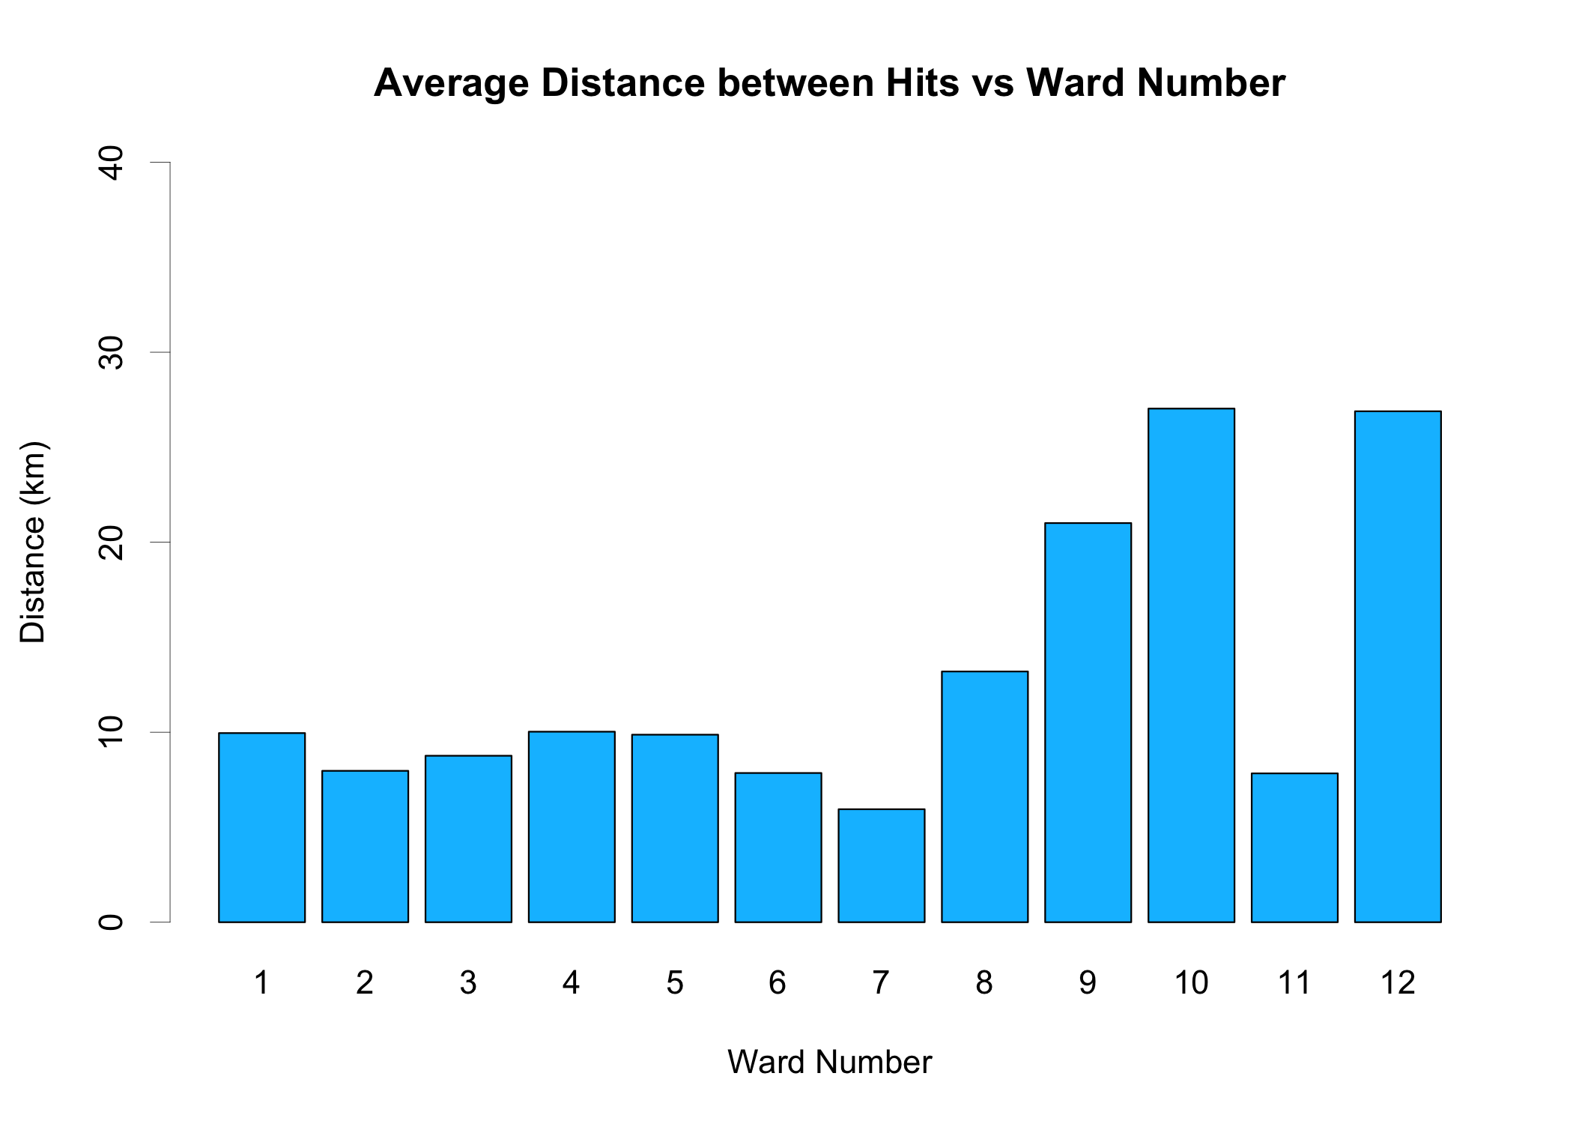

## Appendix D – Multiple Poisson Regression Calculations of all Independent Variables on Hits

The spreadsheet requires some modifications that are easier done in software. All runs covering multiple neighborhoods need to be separated, as each neighborhood will have its own set of demographics. The distance ran for that particular neighborhood needs to be estimated from the overall pace of the run.

## Mac SSD:Users:rbo:Desktop:poisson.jpeg

## Appendix E – Non-Study Related Goals

In this section I will informally explain all the other motivating factors that inspire the project. Obviously if I am writing for a scientific journal, this section is irrelevant and should be excluded. However, I am hoping to indulge a few readers to look at some of the more humanistic aspects of this particular study.

**To Inspire a Fitness Program**

Running is a big part of my fitness program and I used the study to help motivate running. Fitness programs are easy to start but difficult to sustain and the idea of having a study would be another motivating factor. I found the melding on an intellectual goal and a physical goal extremely compelling, especially on days when one would rather do something else. When I was discouraged with the study, the fitness aspect would pick me up. When I was sore or injured or just not running well, the study would remind me to not miss too many days.

For example, I managed to injure myself for 3 weeks in March 2018. With a regular running program, I would have quit and run the risk of not going back to it. But the study said, “you could still walk those neighborhoods”, which is what I did. The transition back to my running program after the injury then became seamless.

Most runs I take easy and enjoy. I will pace at 6 minute 30 second kilometers but sometimes I throw in a tempo run at a 5 minute 30 second pace which is fine as long as my breathing does not labor. My longest continuous run was 18 kilometers at Twin Brooks. I purposely planned many long runs to finish with a good half hour walk as a form of cool down. Because I am still recording hits, I actually looked forward to the easy cool down! This is so different than before when I viewed the cool down as optional depending upon how one felt physically after the run.

In terms of weight loss, I started at 212 lbs. and finished the study at 207 lbs. My pulse went from 55-65 to 50 at the end so at least some level of improved fitness was attained. I also had normal blood pressure and felt great physically and mentally.

**Lowering Cholesterol**

Much to my disappointment, my strenuous running program is not able to keep my cholesterol levels from rising. I was prescribed the next level Lipitor dose in spring 2019. One of the side effects of statins is increased muscle soreness, which has a big impact on my running. I managed to convince my doctor that with particular attention to my diet (I have a big garden of veggies), and with increased quality runs over summer that I could get my LDL cholesterol to the target value. So here was yet another incentive! But this time it ends in failure as my LDL shows no sign of improvement, another victory for genetics. ☹

**Business Aspects**

I felt my data would give me an advantage and perspective on the new cannabis industry. To test this theory, I invested in some cannabis stocks at the beginning of 2018.I was curious to see if legalization would unlock a hidden market that would help the industry flourish. But Oct 17, 2018, was not the day I expected. In terms of cannabis counts, it felt like a normal day in residential Edmonton (see Appendix A).

I sold all my investments that day and decided that unless there was evidence to the contrary, cannabis legalization was going to be a non-event.

I did not have to wait long as the Christmas season approached and all my counts were going up. Since this also happened in 2017, I decided that this was a signal to re-purchase depressed cannabis stocks. The plan was to buy and hold for one quarter because people would probably not account for the effects of seasonality. This was a calculated risk but it was also a test of faith. Did I believe in this data I collected or not?

The other curious business aspect of the study is to compare where the retail stores are located in relation to the hits. Do the hits influence where the stores are, or have the location of stores influenced where the hits are? I will leave it to the reader to compare Figure 9 with the figure below (taken from potguide.com).

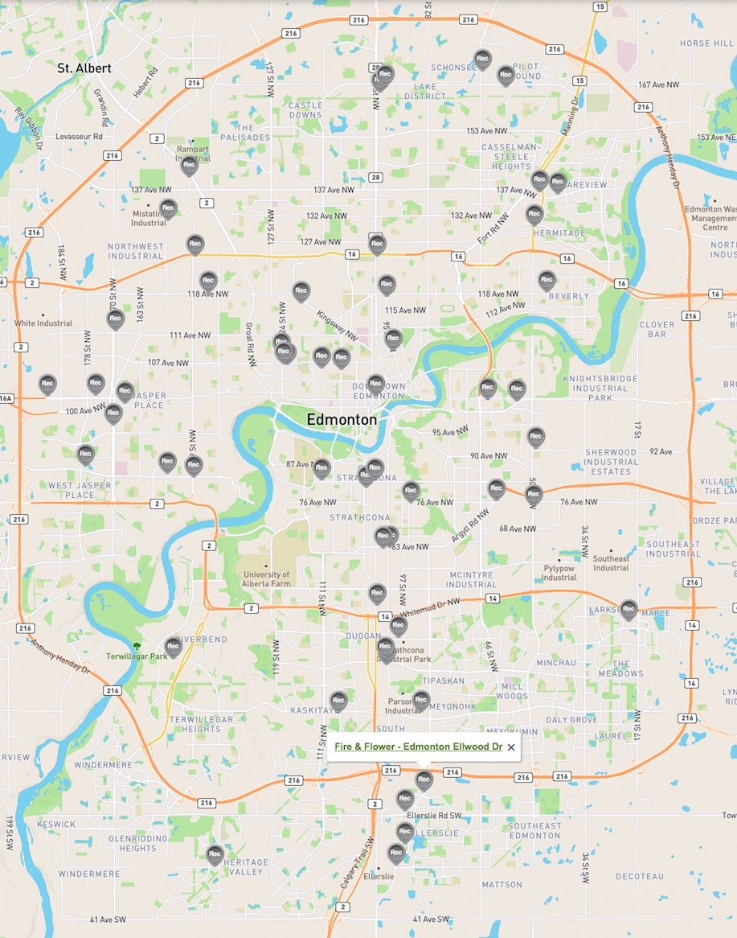

*Location of cannabis retail stores in Edmonton, December 2019*

**Running all the Neighborhoods**

Although 4500 kilometers in two years is a goal most marathoners and ultra-marathoners would surpass easily, I found a lot of inspiration in running all the neighborhoods twice. Not only is it a bit of a crazy running goal but also helps explain why the study did not focus on representative neighborhoods for its data. It was a defined goal that was just barely in reach and this helped me to stay focused.

From the statistical viewpoint of the study, there is no reason to run every single neighborhood. It is not just running kilometers, but it ties in the notion that the route matters! So for me, the medals for this unique “ultra marathon” are Figures 8 and 9.

**Experiencing the city from a different view**

I have lived in Edmonton my whole life and yet there are so many parts I haven’t seen. Those neighborhoods I have seen are usually viewed from the seat of my car, which is not the same rich experience as running. How this factor influenced data collection is that I would not necessarily choose to run the same route of a neighborhood if there was an opportunity to see a different part of that neighborhood.

Here is a really brief list of things I discovered about Edmonton.

1. I liked running in neighborhoods with high concentrations of visible minorities because the people had so much energy! Whether it was in the form of seniors out for a walk, or kids shooting hoops in their driveway, or the distinct smells of Indian cooking, it made my running more enjoyable.
2. I loved the newer communities (South Terwillegar and Rapperswill come to mind) that had smaller homes with verandas and had a tree, the sidewalk, and then another tree before getting to the roadway. These high-density neighborhoods look great now and they will look even better with maturity.
3. I always felt happy to see communities with community gardens and those that were structured to have businesses within walking distance. I could never understand why the city would design a community that had no green space or playgrounds. All neighborhoods with towering elm trees are fortunate.
4. Sidewalks – On more than one occasion, I have fallen face first having tripped on uneven sidewalks. I am concerned the city will not be able to keep up with infrastructure commitments.

Finally, here are some particular memorable moments from the project.

1. One of my first runs, I was confused in an unfamiliar neighborhood late at night, -18C, and a dead battery on my Garmin watch. That was a wakeup call to be better prepared!
2. Seeing a toddler’s first walking steps on the sidewalk, seeing and participating with the excitement of the dad.
3. I was running at night in a blizzard and my glasses kept fogging up. I fell 4 times; the last fall hurt my elbow for about 2 months. You do not need your elbow to run.
4. I was mesmerized by the pickup soccer and cricket games during my run in Silver Berry. Some old guys there. This just does not happen anymore.
5. There are 3 cars on a quiet 4-lane road. It is the afternoon, I am wearing white, and I am crossing in a marked crosswalk. Something tells me the northbound car is not stopping, I stop. Sure enough, he would have hit me. As I proceed in crosswalk, southbound car also is not slowing down. I stop again; this car would have hit me. Car 3, who sees the whole thing, was blaring his horn at car #2 but to no avail. There should be a study on distracted driving!
6. Running at -35C and getting frostbite in the tiny space between my glasses and balaclava. I had red slits under my glasses for the next 10 days.
7. Tripping on a power cord on a very cold night in a poorly lighted area. I don’t fault the homeowner for running the cord, but having it under a mat sure would have helped.
8. Running with geese for about 100 meters, they were too slow so I passed them. Photo below.

